 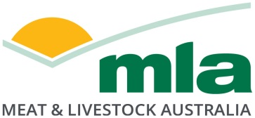

**Final report**

**Evaluation of on-farm sensing devices using mobile technology**

Project code: P.PSH.1143

Prepared by: Harry Evans

Stanbroke Pty Ltd

Date published: 28 April 2021

PUBLISHED BY

Meat and Livestock Australia Limited

PO Box 1961

NORTH SYDNEY NSW 2059

Meat & Livestock Australia acknowledges the matching funds provided by the Australian Government to support the research and development detailed in this publication.

1. This publication is published by Meat & Livestock Australia Limited ABN 39 081 678 364 (MLA). Care is taken to ensure the accuracy of the information contained in this publication. However MLA cannot accept responsibility for the accuracy or completeness of the information or opinions contained in the publication. You should make your own enquiries before making decisions concerning your interests. Reproduction in whole or in part of this publication is prohibited without prior written consent of MLA.

# Abstract

1. Stanbroke completed a trial of two types of on-farm sensing devices to develop a business case and determine the wider industry benefit to producers looking to install similar technology. As the Australian red meat industry battles with increasing costs with labour in the top three costs in any business, this project shows that remote sensing technology does reduce the time spent manually checking water points. There were initially sixteen sensing devices tested over two locations using a mixture of connection types (satellite and cellular). The estimated savings to the business were calculated using the decreased distanced travelled by the bore runner multiplied by the labour and vehicle expense of manually checking the waters.
2. A key finding of this project is the validation that every watering point is different therefore requiring a different monitoring system. Aside from a choice in sensing technology, the type of watering point is also a consideration with many different natural and man-made livestock watering solutions requiring specific attention.
3. At the conclusion of the project the wider industry benefit has been realised after being evaluated at large scale. On-farm sensing devices can have immediate improvements on multiple factors including improved labour allocation, decreased monitoring costs, new ability to prioritise repairs and maintenance, improved decision making, improved confidence in water security, access to previously unknown information (such as microclimate rainfall) and improved visibility for property stakeholders.

# Executive summary

The purpose of the project is to evaluate and compare the application of mobile technology to increase labour efficiency and measure this using dollar values to then justify a larger connectivity project. The results from this project will allow a vertically integrated beef operation to calculate the benefit of connectivity and move forward on potentially much larger connectivity initiatives.

The proposed solution being evaluated uses a combination of two different devices; one is a visual camera (see Figure 1a) and a second a tank level sensor (see Figure 1b) that will be used to remotely monitor stock water levels across to two trial sites. The objective is to use the devices to collect data and then analyse the results to be used in a business case study. The outcome has been the successful collection of both graphical and numerical data which has been interpreted to save distance travelled by staff members in the attempt to increase labour efficacy. A medium-term time period has been established with the mobile equipment operating without experiencing any downtime issues including no breaks in connectivity however there has been some limited hardware issues as outlined later in the report. The assessment undertaken as part of interim business case has demonstrated that Stanbroke has seen up to a 60% reduction in the need to manually check watering points which allows better use of the highly skilled staff members’ time. The final testing phase further supported the business case of utilising remote sensing technology to monitor livestock water systems. Although the Tank monitors have proven to have more time savings, any device is beneficial to a business if used correctly and personal preference needs to be considered before implementing a particular solution.

1. 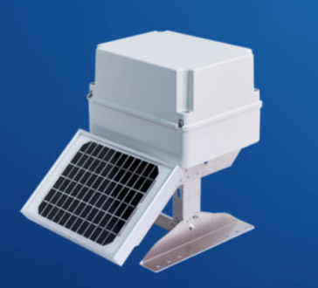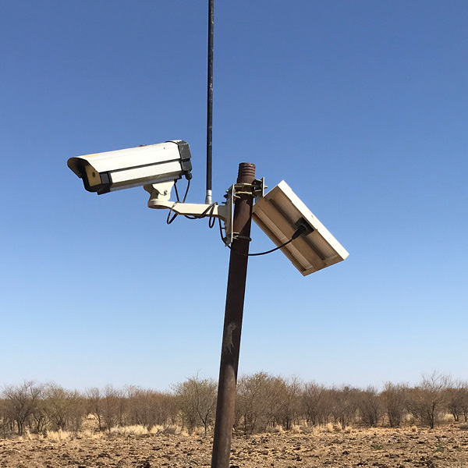
2. **Figure 1a and 1b**:Application of mobile sensing technology to monitor stock water levels across a vertically integrated beef property, consisting of a) visual camera and b) tank level sensor.

It has been shown that at the completion of the project that each solution has provided an immediate production efficiency and labour savings to the business by reducing the time spent routinely checking watering points and better utilisation of labour across the business. Furthermore, the data collected has been used to improve water management practices across the properties by evaluating stock watering usage rates real time against rainfall. The second stage of the project included an extended commercial pilot monitoring and evaluation period of the mobile sensors over a test period of 2 years. At the conclusion of the project the wider industry benefit has been realised after being evaluated over several commercial scenarios at large scale. On-farm sensing devices can have immediate improvements on multiple factors including improved labour allocation, decreased monitoring costs, new ability to prioritise repairs and maintenance, improved decision making, improved confidence in water security, access to previously unknown information (such as micro-climate rainfall) and improved visibility for property stakeholders.

It is recommended that further expansion of the current network of monitors is undertaken. This should include more of the same equipment (tank monitors and rain gauges), as well as new systems to work with the existing infrastructure. The long-term goal would be to have near-real time data on every major water point with the ability to remotely send a signal to the site (such as switching a pump on/off). Some of the aforementioned benefits cannot be completely utilised until an entire system or geographic area is connected with monitoring devices thus allowing complete visibility of the situation and avoid any unnecessary vehicle hours.

Future research and development should be focused on highlighting more benefits of connectivity to build a better business case for producers to seek better services. Increasing the benefit as well as reducing the cost of connectivity increases the financial return for projects such as this and will be what drives the red meat industry forward into the phase of growth.

Table of contents

Abstract 6

Executive summary 7

1. Background 10

2. Objectives 11

3. Methodology 12

4. Results 13

4.1 Detailed trial schedule and commission on-farm sensing equipment 13

4.2 Data Collection and Analysis 16

4.3 Interim Business case 19

4.4 Commercial pilot trials, test and monitor 21

4.4.1 Trial Site 1 – Cameras 22

4.4.2 Trial Site 2 – Tank Monitors 23

4.5 Updated Business Case 24

4.6 Reliability and Robustness of the Technology 25

4.7 Comments from Managers 26

4.8 Next Stages 27

5. Discussion 29

6. Conclusion and Recommendations 31

6.1 Conclusion 31

6.1.1 Initial Stage 31

6.1.2 Final Stage 31

6.2 Recommendations 32

7. References 33

8. Appendix 34

8.1 Farmbot Tank Monitor 34

8.2 uSee Camera Monitor 36

# Background

Stanbroke is in the unique position (due to geographic location) to have mobile phone (3G) coverage on a small part of one of their properties which has utilised the trial technology. While the rest of the portfolio relies on the more expensive satellite communications system, both systems will be trialed. While 3G capability substantially reduces the cost of telecomunications which allows for a more cost effective operation of the on-farm sensing devices, the satellite options provide a more flexible solution suitable to many producers that lack cellular coverage. Both options have been shown to be commercially viable for the wider beef producing community.

Stanbroke monitored time and kilometres travelled for the bore runner role therefore calculating the cost of checking waters at the beginning of the project. On average they currently travel upwards of 350kms twice a week to check the waters at a cost of over $1000 per week. To reduce the need to routinely check the waters Stanbroke installed eight cameras at eight different watering points. These devices utilised the 3G network to send three images per day of the water and its source back to the homestead. This allowed bore runner operators to better manage their time while only having to inspect the bores and other watering points once a week until confidence was gained in the system. Once the sensing technology had proven to operate accurately and reliably, then it was propsoed that watering points are likely to manually inspected only when the sensors signal there is a water flow issue or shown to be faulty by the system. Tank level monitors were also installed in eight locations on the second trial site to establish the difference between technologies in terms of effectiveness and reliability. The tank monitors provided almost real-time capability to measure levels of water in the tank and this was used to determine if there was a problem or if the pumping system needed to be operated to maintain the requried water levels.

The success of the project was measured in terms of cost savings to business in labour savings and operational efficiencies. The primary benefit to the farm operations was expected to be the reduction of kilometres travelled in the bore runners’s vehicle for checking water and the amount of time used to monitor. Any labour savings is expected to be used elsewhere to better utilise farm operators skills. The project proposes to evaluate mobile technology to increase efficiencies by reducing labour to demonstrate to Stanbroke and justify the benefits of connectivity paving the way for potentially larger connectivity projects. The overall objective is about demonstrating mobile technology using cameras and sensors over a range of property monitoring and management practices across up to two of the Stanbroke properties over a range of scenarios.

# Objectives

The overall objective of the project is to utilise mobile technology to increase efficiencies by reducing labour and enhancing on-farm safety to demonstrate to Stanbroke and justify the benefits of connectivity paving the way for potentially larger connectivity projects for indeed wider industry.

The specific objectives are:

* To demonstrate the application of mobile technology to collect, transmit and store data from remote farm locations specifically to monitor and manage watering points
* To evaluate farm sensing equipment over a series of trials to determine the accuracy, reliability and robustness across two properties and a range of scenarios.

The purpose of the project is to evaluate the application of mobile technology to increase labour efficiency and measure this using dollar values to then justify a larger connectivity project. The results from this project will allow a vertically integrated beef production business to calculate the benefit of connectivity and move forward on potentially much larger connectivity initiatives.

The results from this project will allow Stanbroke and the wider industry to determine value proposition and benefits of connectivity to potentially invest in larger scale connectivity future projects.

# Methodology

The project approach was applied in the following stages:

1. Detailed trial schedule and commission on-farm sensing equipment. Training on equipment use and setup and test live data streaming. A preliminary report approved to project group including detailed trial design.
2. Evaluation of sensing equipment in on-farm applications. Run trial, collect data and data analyses over a six-month period. A preliminary report on the evaluation of sensing equipment and field testing in various on-farm applications approved to project group.
3. Final interim report and present business case to Stanbroke Exec team and industry. A confidential interim final report submitted to project group to include:

* Results and findings on on-farm field trials and evaluation of sensing equipment in on-farm applications
* Internal business case and cost benefit
* Recommendations for future application of mobile technology in Stanbroke and the wider industry
* A public final report that is approved by MLA and Stanbroke for industry release including using mobile technology and benefits.

1. Monitoring of the mobile sensors and data analytics for a test period of 2 years.

# Results

## 4.1 Detailed trial schedule and commission on-farm sensing equipment

The objective of the initial stage was to commission the equipment. The outcome has been the successful installation of mobile sensing equipment at two trial sites each on different large scale beef properties. The sites were chosen to maximise the reduction in kilometres travelled to check the watering points.

The installation of the equipment was quick and easy for both the tank monitors as well as the cameras. The tank monitors secured directly onto the roof of the tank and were supplied already preconfigured ready for operation.

The devices were found to be incompatible for sensing of the turkey nests, which were initially a strategic priority for use of the technology. The sensors were required to be considerably modified in order to monitor water levels at large mass therefore impractical for the trial. The devices were moved to other strategic positions across the property to reduce time spent travelling to check watering points.

Installation was relatively straightforward with the cameras taking approximately 10-15 minutes to install each if an elevated anchoring point was already available to secure the camera to. An additional hour was required to erect a post or elevated securing point from scratch using a post hole driver and a length of railway iron high enough, so the mature cattle could not reach which was determined to be three metres. The tank monitors took about 15 minutes to install (see Figure 2).

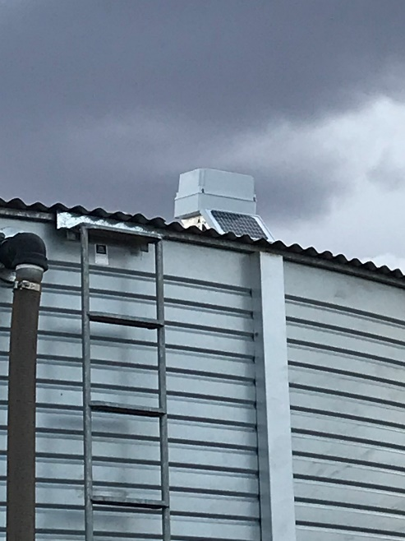

**Figure 2:** Tank monitoring devices secured to the roof of tanks.

There were initially barriers to adoption of the monitoring technology by station managers and property operatives at first due to recent personnel changes at both trial sites and day-to-day jobs being prioritised before focussing on new systems and processes. Consequently, the project in the initial setup stage was at the end of a long to do list for the new managers. The cameras needed to be fixed to an elevated anchor point, which was an additional task to be erected on top of the day-to-day priorities. Initially the plan was to install three tank sensors and six monitors for the water storage facilities (i.e. turkey nests). An added complication was that the large water storage areas were plastic lined, making it impossible to erect a post through the plastic lining. It was decided to relocate the large water storage water monitors to alternative tank applications.

After the successful installation of mobile sensing equipment at two trial sites, a short run time period established that the mobile equipment was operating correctly with only one downtime issue recorded, however no breaks in telecommunication connectivity. This outage was the consequence of birds destroying the external cabling and breaking connection. A steel box was manufactured and installed to protect from further destruction (See Figure 6a). Once installed, the tank sensors were trialled for a continuous period over approximately 12 days to monitor at trial sites including the tank shown in Figure 3. There were no issues experienced with data capture or reading the output dashboards. The early trial demonstrated that once the average use and time to fill was established the tanks monitors made it easy to alert that a problem exists via email and text messages when the tank is full and/or if the tank is low. The tank sensors were also set up to collect rainfall data that allows property operatives to monitor property microclimates (See Figure 4).

**Tank 1**

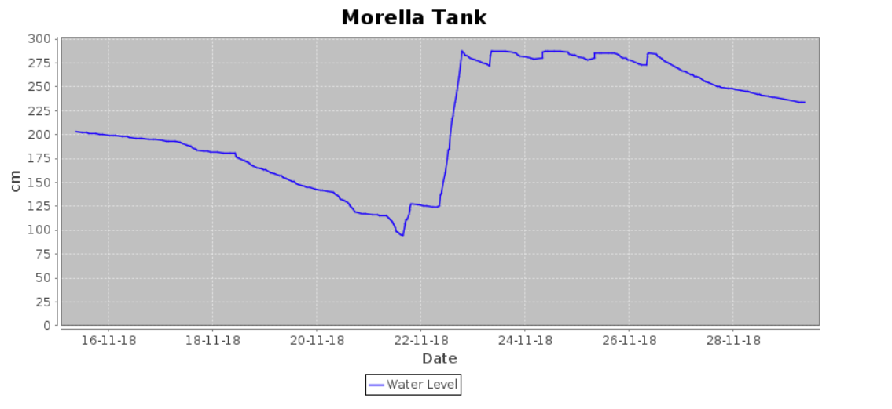

**Figure 3:** Water levels monitored at one tank trial site over an interim trial run time of approximately 2 weeks.

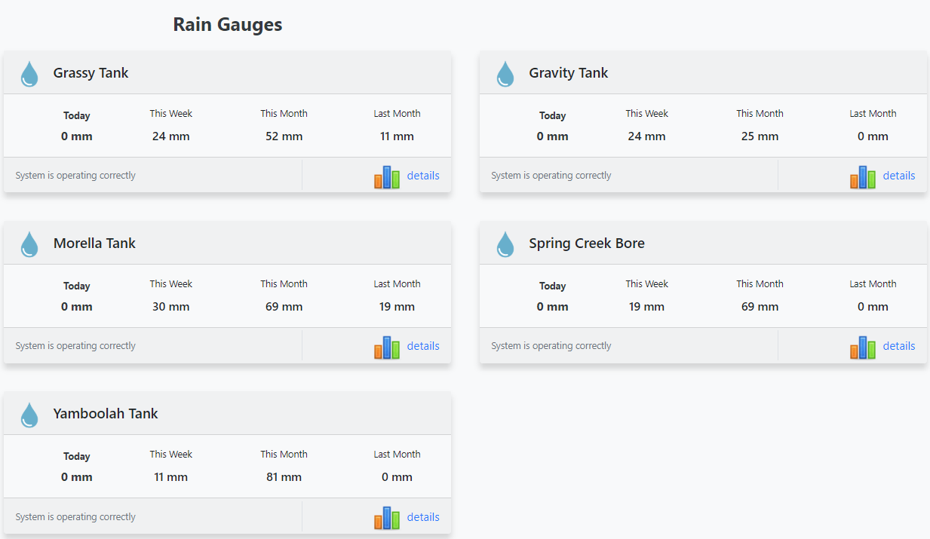

**Figure 4:** Water levels of rain gauges monitored located at several tank trial sites.

The preliminary runtime trial demonstrated that the cameras have been sufficiently sensitive to detect water management non-compliances and providing real-time alerts to allow the problem to actioned immediately. The associated direct benefits of this new management practice using visual sensors (instead of manual monitoring) are expected to be reducing running costs of vehicles and the increase labour efficiencies (refer to Figure 5a, b).

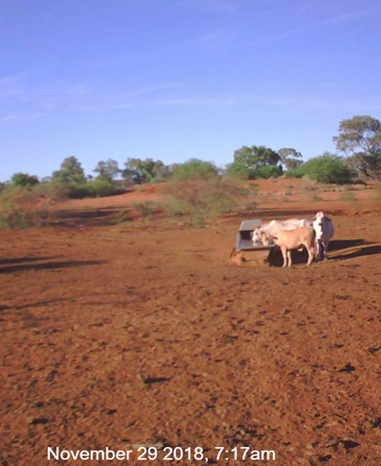

**Figure 5a,5b:** Visual real-time (3 updates per day) monitoring of water supply at two trial sensor sites.

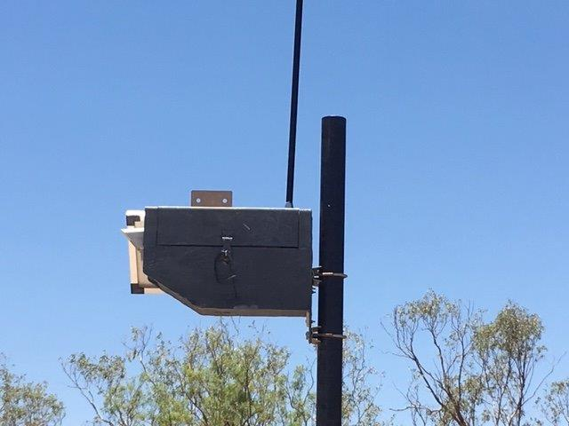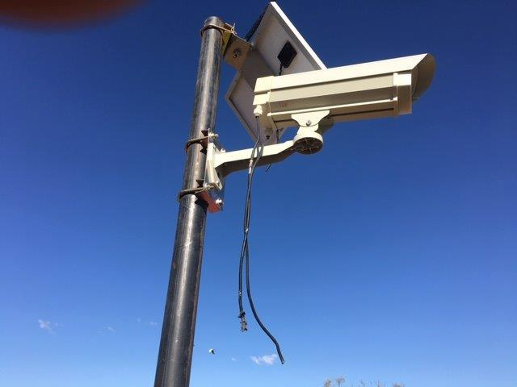

**Figure 6a:** Visual tank camera with cables disconnected by birds; **6b** Visual tank camera including cables housed in a steel box case.

## 4.2 Data Collection and Analysis

The objective of the second stage was to evaluate the equipment and its value to the business. To be able to achieve this objective, a monetary value was placed on the device’s use. This was able to be achieved by calculting the value related to time saved from reducing the need to visually check the watering points. Current best practice being used across property operatins was to inspect these watering points twice a week and more frequently during higher evaporative periods during the dry season (i.e. as the surface water evaporates during the dry season the watering points needed to be checked three times a week).

There is a large demand on labour which is currently attributable to typically one bore runner operartor (equivalent to 1 full time employee) who is in charge of making sure all livestock have access to water. Manual checking of water points is time consuming and costly and not the best use of a highly skilled bore runner operator’s time (who is usually highly skilled). The sensors demonstrated an ability through the pilot trials to reduce labour by up to 60%. In some circumstances this allowed bore runner operators to better manage their time resulting in only having to inspect the bores and other watering points once a week once confidence was gained in the system. Once the sensing technology was proven to operate accurately and reliably and it monitoring an entire system, it is propsoed that watering points are likely to be manually inspected only when the sensors signal there is a water flow issue or shown to be faulty by the system.This outcome could not be observed due to other waterpoints that did not have devices installed still requiring manual checking. The current water run at trial site 1 where the cameras are places is aproximately 240kms and trial site 2 where the tank monitors are the water run is similar round trip (Refer to Figures 7a and 7b).

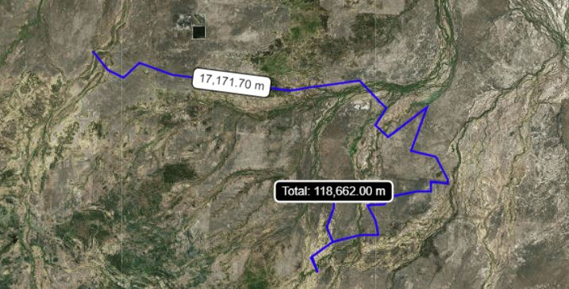**Figure 7a** Trial site 1 for water sensing pilot trials

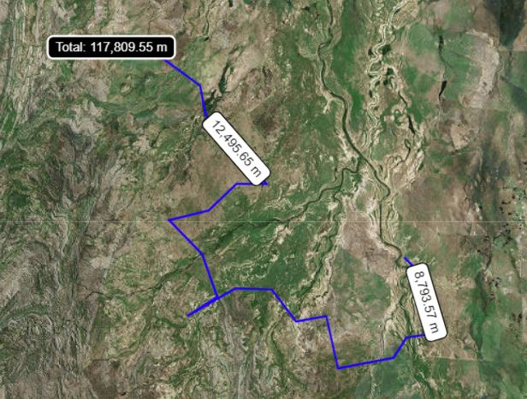**Figure 7b** Trial site 2 for water sensing pilot trials

The devices provide two different types of data, the camera provides an image, while the tank level provided data displayed in a graphical form with both options being used to diagnose problems. Figure 3 is an example of the data provided by the tank sensors. This data shown is an example where the cattle have been drinking to reduce the level in the tank the pump has been turned on and the water level increased (see Figure 3).

It was expected by having access to such on-line sensing data, there would be no need to physically check water levels unless there was unusual and unexpected data (i.e. abnormality in the graph). The short run trial demonstrated that once the average use and time to fill was established, the tank monitors made it easy to alert that a problem exists via email and text messages when the tank is full and/or if the tank is low. For remote application, an SMS is not possible as there is no mobile phone reception. The expectation of the removal of manual routine inspections could not be validated in this project due to many other nearby water points still requiring manual inspection. Although the monitored points were still manually inspected as the bore runner was going past anyway, the presence of the sensing equipment reduced the time for each stop as the driver already had information on the location before leaving the homestead. This information allowed the correct equipment to be taken if a problem was identified therefore reducing kilometres.

The outcome of the data collection and analyses stage has been the successful collection of both graphical and numerical data, which has been interpreted to save distance travelled by staff members in the attempt to increase labour efficiency. The short run time period has established that the mobile equipment was operating without experiencing many downtime issues including no breaks in connectivity. However, there were some limited hardware issues experienced during the trial period.

## 4.3 Interim Business case

The success of the project was measured in terms of cost savings to business in labour savings and operational efficiencies. The primary benefit to the farm operations was the reduction of kilometres travelled in the bore runners’s vehicle for checking water and the amount of time used to monitor. Any labour savings were used elsewhere to better utilise farm operators skills.

To evaluate the systems, Stanbroke calculated the kilometres saved from the monitors on the water runs. Stanbroke calculated the cost associated with undertaking the bore run and watering points’ checks on a per km basis.

**Table 2:** Estimated cost per kilometres for a manual bore runner operator checks

|  |  |
| --- | --- |
| **Expense** | **Cost per KM** |
| Tyres | $ 0.04 |
| Fuel | $ 0.25 |
| Servicing | $ 0.10 |
| Depreciation | $ 0.15 |
| Wages | $ 0.78 |
| Total $/Km | $ 1.32 |

Assumptions applied include:

* Tyres are $1600 per set with an average of 40,000 kms
* Fuel is calculated at 6km per litre at 1.50 per litre
* Depreciation is the as per the ATO
* Wages are $250 a day at 8 hours a day travelling at 40kms per hour

These dollar figures per km were used in the results to evaluate the technology.

The amount of water runs (trips to check waters) saved depends on when the break in the season happens as the surface water dries up and cattle are more heavily reliant on the water troughs as demonstrated in Figure 8. During the trial period, there was a later than usual break and the trial sites didn’t see large amounts of rain until February.

**Figure 8:** Predicted amount of water runs saved by the monitoring technology

The number of water runs in Figure 8 above are based on the following assumptions:

* No runs are saved during the wettest three months of the year
  + Water runs are usually low in this period anyway with restricted vehicle access to some parts of the property and sufficient ground water for livestock
* 6 months following the wet season save on average 4 runs per month
  + this assumes that a bore run is usually completed twice a week without monitors and only required once per week with sensing equipment
* 3 months at the end of the season usually require 3 runs per week
  + Initial predictions suggested approximately 2/3 of bore runs will not be required

Using the above assumptions, the Net Present Value has been estimated as seen in Table 3. The yearly savings used is calculated as: Yearly Runs Saved * Cost per Km * Km per Run. The cost component of the calculation includes 8 of each device and the yearly ongoing charge for the service.

**Table 3:** The net present values discounted at 6%



When it comes to assessing different types of technology there are many factors in which to consider where ease of use, reliability and financial viability are the key drivers. Both systems are very reliable and are easy to install, the tank monitors do require some skills in reading the graph and determining what the problem is as opposed to seeing the picture. This added skill makes the tank level monitor slightly harder to use however, the numerical data in which it provides adds value and can be used to add value unlike the camera, which provides only a photo. The real time data the tank monitors have theoretically is an advantage in terms of reaction time; however, on a station, you cannot always react as quickly, to make this useful therefore, the lag of three photos a day does not create a practical problem.

Using reduced kilometres travelled is the simplest way to calculate the benefit from the remote sensing however there are added benefits including better allocation of time for staff and decreasing lone worker risk. Freeing up skilled labour such as bore runners allows them to focus on improving water systems and maintenance which sometimes gets put to the end of the large to do list. Safety is also a big concern on remote cattle stations and lone worker risk is particularly high when it comes to checking waters. Both safety and opportunity cost of labour are both quite subjective however it is known that they are another added benefit for remote monitoring. Another side note is that as more technology is added to stock watering systems it becomes more interesting to the next generation of bore runners.

In summary, the results show that over a 5-year period there is not much difference between each system. Over the short term the lower initial cost of the tank monitor does provide a quicker payback period however, the higher cost of the ongoing telecommunication makes it more expensive over the long run. There is a cellular option, which would reduce the ongoing cost slightly. Additional work to make water monitoring more cost effective will need to focus on the reduction of the communication costs this can be done by either “dollar cost averaging” which involves increasing the amount of useful data you get from the 1 connection or by reducing the overall cost of the connectivity. This is being explored in Long-range wide-area network (LoRaWAN) and point to point connectivity solutions or even low orbit satellites. These new technologies specifically LoRaWAN, allow wireless communication between compatible devices over large distances with minimal battery usage. The limitation of the system is the restricted data transfer rate, which is achievable over the network, although in applications such as sensing/monitoring this may not be an issue so send/receive a small number of messages (1-5) per day about current usage (Science Direct, 2019). Figure 9 below outlines that the data collected by the long-range network can be transferred to existing communication infrastructure to provide feedback via notifications or an application. The last link in the system is vital as the collected data needs to be transformed into usable information that key stakeholders can easily view and understand. Further research has been completed into the setup of a LoRa network and the biggest hurdle would be the upfront infrastructure cost. As at the time of the project the technology currently requires a tower every 8-10km to transmit the signal.

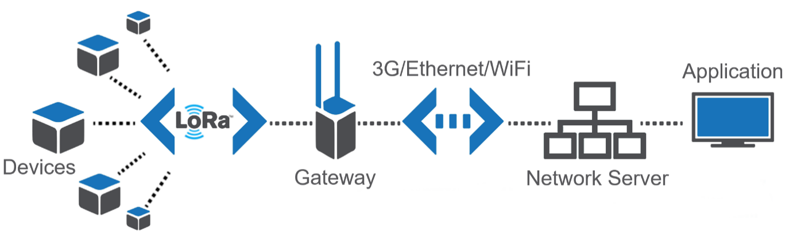

**Figure 9:** Network of LoRaWAN devices interacting with existing communication infrastructure  
(Science Direct, 2019)

## 4.4 Commercial pilot trials, test and monitor

The use of both remote sensing solutions was continually monitored throughout the remainder of the project by Stanbroke’s Digital Officer, Station Managers, Head Stockman, and individual Bore Runners. Original predictions and findings from the earlier short term testing period suggested that the installation of monitoring equipment would reduce the number of water runs each week. However, after a longer period in the field and the station managers/bore runners gaining confidence with the systems, it was found that the same number of trips were occurring each week but the time and number of kilometres per trip was reduced. As only a limited number of devices have been installed there are still requirements for the bore runner to regularly check un-monitored watering points, although due to the strategic placement of the installed devices it has given the driver the opportunity to review the data before commencing their trip and decide if that section of the bore run needs to be completed. One challenge has been staff turnover with multiple new bore runners at each trial site since the monitors were installed. The seasonality of the job and the remoteness of the properties can sometimes make it difficult to retain bore runners from one season to the next. In the absence of a dedicated bore runner position either the station manager or a member of the stock camp would undertake the bore runs on an ad hoc basis. The break in a continuous operator had some impact on the potential kilometres saved as each new or inexperienced staff member that conducted the bore run would need to personally gain confidence and understanding in the monitoring systems before the kilometre reduction were witnessed. Specifically, in the dry time of the year the Tank monitors have proved more useful due to increased frequency of information and the combined data of rainfall and Tank levels. As expected, kilometre and runs per week have increased in this period but are still between 1-1.5 times less than before the monitors were installed. During the wet season the number of water runs decreased compared to the dry period and the tank level monitors at trial site 2 were again preferred to the camera monitors as each device had an attached rain gauge. The rain gauge allowed managers to view and record localised rainfall over the wet season without having to visit hard to access locations. This in turn lead to a cost saving from reduced helicopter hours over the wet season. While the camera monitors were able to visually show that there had been rain there was no quantitative way to measure the actual rainfall. Following the wet season, surface water started to dry up and stock reverted to troughs and dams. During this period where water and pasture availability was constantly declining, this further showed the importance of the remote monitors in areas that were either low on feed or temporarily heavily stocked due to market availability inconsistency, allowing water consumption to be monitored closely. The last stage of the project proved that even during the wet season the water monitor devices can prove very useful. The relatively underwhelming rainfall compared to forecasts meant that some properties had to shift cattle during the wet season to certain paddocks that had feed available which changed the normal watering pressure in those paddocks. The monitoring devices allowed the impact of those changes to be monitored while also reporting back very important localised rainfall events as they were happening.

### 4.4.1 Trial Site 1 – Cameras

The bore runner at trial site one averaged 1000km per week at the commencement of the project, this figure is slightly higher than originally predicted to be common practice before the cameras were installed. The staff member on this run only recently started with the company in the trial period and is still learning the unique supply and demand requirements for each watering point. While in this learning phase they were still travelling to sites with and without cameras installed at the same frequency. In the period where the station did not have a dedicated bore runner the cameras were highly valued by the manager as they could prioritise sending a member of the stock camp away from their usual duties to attend a visual problem seen from the cameras. The benefit of the cameras is also utilised when there isn’t enough time to travel to every watering point and allows the bore runner to visually inspect the trough before making the decision to include it in the particular water run. Trial site 1 observed the demand on the water system increased starting from October onwards in the first year. The increased demand in-turn required extra maintenance to be performed on water points which increased the time spent getting parts, repairing, and returning the system to an acceptable performance. Although the number of sites visited did not reduce, visually identifying the problem before leaving the station complex reduced the kilometres travelled when the correct tools and parts were taken to fix the problem on the first trip. As the cameras reached over 12 months old there started to be a few issues. As at the completion of the project only 2 of the original 8 cameras were operational. A range of issues have been identified with the faulty cameras including: Old Batteries, Bird damage to external wires and faulty camera modules. Another issue with the operational cameras was the need to be cleaned to produce visually useful images. At the time, Stanbroke obtained quotes to repair the faulty cameras, however the cost to repair the cameras was considered non-viable and could not justify the cost for the benefit received from the cameras. There may be an opportunity to repurpose the remaining cameras for creek or river crossing in preparation for an upcoming wet season. This would allow a staff member to view the camera image to visually assess if the crossing is accessible before leaving the homestead and potentially plan a different route. This could save up to 100km per trip if the river crossing is not able to be accessed. The opportunity to repurpose the remaining cameras was low in priority due to other critical activities during the trial period and it was unable to occur before the completion of the project.

### 4.4.2 Trial Site 2 – Tank Monitors

The bore runs at trial site 2 have been reduced by between 100 to 150 km per trip using the graphical data supplied by the tank monitoring system. The placement of the monitors are near the ends of each run which when the monitor indicates everything is operating as normal eliminates the need to travel the entire run. The number of trips per week have not changed although the saving has been seen in the reduction of time and kilometres per trip as mentioned above. Where one trip may have taken a full day, with the added insight from the monitors the bore runner now has the afternoon free to perform other duties. The extra set of hands that would usually be driving have been utilised to distribute lick supplements, manage woody weed problems and help with other ad hoc workshop and maintenance jobs. The station manager checks the graphical dashboard each morning which has allowed them to become familiar to the trends of each unique water system connected to the monitored tank. The available ground water started to dry up from August and increased demand on both the bore runner and water system. The ability to recognise variations to the usual pattern provides the manager valuable information needed to prioritise important or high value problems without using the time to drive to each water point. At the period of testing the season created increased pressure on all water points and as such the tank monitors have become a vital part of the water system. As mentioned above, once the wet season had begun this naturally reduced the number of water run kilometres travelled each week. The attached rain gauge proved valuable as they allowed staff to view and record localised rainfall over the wet season without having to visit hard to access locations. Figure 10 below shows the recorded rainfall for January 2020 at the most remote monitoring location at Trail site 2. This location is approximately 50km (straight line) from the homestead which recorded noticeably different records. Figure 10 shows a January combined total of 171mm where the homestead recorded 252mm over the same period.

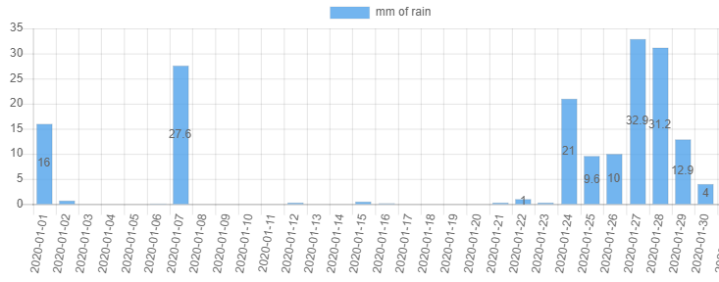

**Figure 10:** Recorded Rainfall from Tank 8, 50km from Trail Site 2’s Homestead

## 4.5 Updated Business Case

As mentioned above the reduction in bore runs has been witnessed not in number of trips but by the time and kilometres required per trip. As can be seen in Figure 11 below the estimated savings follow the same trend as originally predicted in Figure 8, although Figure 11 shows the savings in terms of kilometres per month rather than trips per month. This update is reflective of how the station managers have adapted their practices to utilise the new information provided by the monitors. Figure 11’s values are based on current usage and future months are likely to reduce even further although it is yet to be seen how the new technology will be utilised now that there are more devices in the field. The most notable difference in the figure below is the estimated kilometres saved from the camera system verse the tank monitors, it is to be noted that this is not due to the underperformance of the camera. Trial site 1, where the cameras are installed had a new staff member take over the bore runs at the time of the estimation and as such they were not as confident in the system as those at trial site 2 who have had more time to integrate the monitors into their water run planning. Due to some of the Camera monitors being out of action at the kilometres saved reduced until new devices were installed. Another observation of the cameras is that they were positioned too far away from the water point to accurately diagnose a potential problem. This distance was chosen to capture a wider field of view although if they were to be reinstalled it is recommended to position them closer to the trough so that all components can be seen clearly.

**Figure 11:** Estimated amount of Km saved by the monitoring technology

Based on these estimations and the assumption of an average speed of 45km/hr while on a bore run it is estimated that a bore runner had an extra 5.5 hours each week to be spent doing other productive tasks. The benefit of utilising the bore runner for other labour reduces the need to hire contractors or take staff from other areas of the business such as the stock camp. This estimation of extra hours is a conservative estimate as the kilometres saved is predicted to increase further as more monitors are installed and further confidence is gained in the data provided.

## 4.6 Reliability and Robustness of the Technology

When the equipment reached the 1-year anniversary of being installed on both trial sites both types of sensors have had few technical problems although with very little down time. One of the eight cameras were sent away for repairs after over 12 months on site. It is likely that the issue was with wildlife damage. Two other cameras also had approximately a week down time as the solar panels had been obstructed and the battery was not able to recharge itself, this was able to be fixed the next time the bore runner was driving past by cleaning the equipment. Other hardware problems with the cameras have been described including damage caused by birds and cameras pointing the wrong direction. The tank water monitors have had fewer problems with two devices needing a probe replacement and recalibration. The connectivity of both options has not been observed to have any downtimes caused by the connection type. The only connection down time that was recorded was after the mobile credit expired for the cameras as the 12-month subscription did not automatically renew. This was able to be resolved almost immediately with the cameras back up and running the next day. In the final stages of the trial period, it was found that 6 of the camera monitors had been sent away for repairs leaving only 2 operational. At the same time there were four tank monitors that were having issues reporting water levels. Two of these were blown off the top of the tank by an early storm and were sent away for repairs, the other two have stopped reporting to the satellite and were assessed remotely by the support team. The design team identified a weak point in the design that was causing the devices to blow off in harsh wind. The design has now been changed and the problem has not yet been witnessed with the new devices. There were no reportable connectivity issues at the completion of the project, other than minor delay when installing new monitors.

As mentioned above one of the Stanbroke properties conducting the trial confirmed that only 2 of the 8 cameras were operational at the completion of the project. A range of issues were identified with the faulty cameras including old batteries, bird damage to external wires and faulty camera modules. Another issue with the operational cameras was the need to be cleaned to produce visually useful images. At the time, Stanbroke obtained quotes to repair the faulty cameras, however the cost to repair the cameras was considered non-viable and could not justify the cost for the benefit received from the cameras. It should also be noted that the Usee technology originally installed was sold to DIT Agtech during the trial period which caused some product lines to be discontinued. The new company still provides a similar solution although it is unknown whether the performance and features are comparable to the devices outlined in this report.

## 4.7 Comments from Managers

* How many Km is the bore runner doing per week?
  + KM are starting to ramp up as the season warms up
  + 1300km per week in September 2019
* Does someone check the monitor reading / camera images every day?
  + Cameras - Manager checks it every day with the email, bore runner checks 2-3 times a week
  + Tank Monitors - Manager, assistant manager, Head Stockman and the bore runner check them each morning and discuss how things are pumping
* Have you had and connectivity or technical problems?
  + No Connection is fine, only slow updating due to poor internet at homestead. We have replaced another level probe in this quarter.
  + Yes, one camera sent away in August to get fixed due to birds chewing wires, another camera sent away last year (unsure of issue), a third tank camera hasn’t recorded an image in a week potential battery connection issue).
* If you could install more devices – where would you put them?
  + We would like to install about another 10 units on the western side on some turkeys’ nests. Currently we are driving past bores with monitors on to manually check water points further out without monitors, if we could check all the bores remotely one day then drive out and physically check them in two days’ time would reduce bore run mileage further. We are also keen to purchase some flow monitors before the end of the year.

After discussing with the people on the ground who use the equipment every day it has been found that each water point is unique and requires a custom sensing setup. As mentioned above some nests are not suited to the level sensors and cameras may be more effective. New installation is also underway to include flow monitors to individual troughs which will give more specific information on which part of the network is under stress or operating as normal. Stanbroke has been trialling different methods of using the level monitors for turkey’s nests as already identified as critical water points. The most successful of these trials was a swinging arm that is driven into the wall of the nest which can then place the monitor out over the middle of the water point. This design can be seen in Figure 12 below.

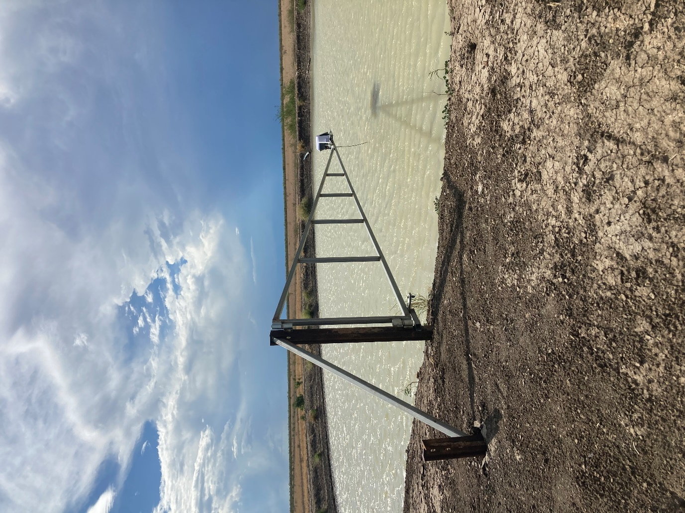

**Figure 12:** One solution for using a tank level monitor and rain gauge on a turkey’s nest

## 4.8 Next Stages

Due to the success of the project, Stanbroke decided to expand its monitoring network in December 2019. Trial Site 1 has ordered 8 new devices that include Tank/Turkey Nest Level monitors, Rain Gauges, and a new feature for Stanbroke a flow monitor. As found in the initial stages of the Project Turkey’s Nest were not compatible as a post would have pierced the lining of the reservoir. After working with the managers and bore runners on site a simple arm on hinges that can be installed on the bank and then swung over the water has been designed. Due to their positioning 3 of the 8 new sites are using a 3G connection and the remaining 5 are to communicate with Satellite as per the sensors at Trial Site 2. Trial Site 2 is also expanding its network from 8 level monitors to include 10 new devices which include level, rain gauge and flow monitors all of which are all satellite. Trial Site 2 also conducted some radio mapping and identified 1 paddock that was able to pick up a 3G connection from the top of a decommissioned windmill (10 meters). This unique location may be used to test a LoRaWAN connection type. By installing a LoRa antenna on the top of the windmill it is predicted to be able to broadcast its signal approximately in a 10km (line of site) radius. Due to a delay in equipment this location was not accessible before the wet season commenced this made installation impractical. The installation of the additional monitors has not seen a reduction of kilometres travelled as other “un-monitored” sites still require checking. The new monitors however have greatly increased the confidence in the water security and availability for the specific paddocks where they are located. An additional 12 tank monitors and rain gauges have been ordered to complete a water circuit in hard-to-reach locations in preparation for the 2021 Wet season. The network of monitors will grow each year at a faster rate as each new site has hardware installed. In the final stages of the project another 21 Tank monitors and Rain gauges were ordered which once delivered will take the number of monitored water points over 50, the number of devices is expected to increase year on year.

# Discussion

As the Australian red meat industry battles with increasing costs producers need to find ways to become more cost efficient, labour is a top three cost in any business and this project shows that remote sensing technology does reduce the need manually checking of water which in turn diverts labour to more effective activities which may be neglected in a time poor environment. Any advance in technology is a good one therefore while the camera does not provide the added data the tank monitor does it does provide piece of mind and more information than nothing at all.

The real outcome of this project is the realisation that every watering point is different therefore it requires a different monitoring system. The type of pump at the watering point is also a consideration where a diesel pump will need to be filled up and turned on and off needing regular attention compared to a solar pump, which can be set with a pressure switch to turn on and off requiring less attention.

Reducing time checking waters has real economic benefit to the any business whether a camera, tank or other monitor is used; it also comes down to the preference of the producer. As the communication cost is a large proportion of the total cost, combining other data using the backhaul of the machine can bring benefit as shown with the rainfall data collected using the tank monitors. As previously stated, you can reduce the ongoing cost by increasing the value you get from the information or by reducing the telecommunications costs. For example, rainfall information collected at each tank monitor can be used to manage the properties microclimates and possibly be fed into a pasture model for carrying capacity calculations in the future.

Stanbroke supports this technology as shown there is a real economic benefit in using remote monitoring technology. Apart from increasing labour efficiencies, it reduces risks for lone workers and could also attract different people to the business.

The objectives of the project were:

* Results and findings on on-farm field trials and evaluation of sensing equipment in on-farm applications - Achieved
* Internal business case and cost benefit - Achieved
* Recommendations for future application of mobile technology in Stanbroke and the wider industry – Achieved
* Testing / monitoring through commercial and pilot trials over a two year period – Achieved

It is recommended that further expansion of the current network of monitors is undertaken. The current network of monitors has grown from 16 to 50+ in the short period of two years, with this expected to continue to increase year on year. This should include more of the same equipment (tank monitors and rain gauges), as well as new systems to work with the existing infrastructure. The long-term goal would be to have near-real time data on every major water point with the ability to remotely send a signal to the site (such as switching a pump on/off).

Figure 13 shows a prediction of how many different monitoring devices can be used together in a network to provide feedback to the end user. Stanbroke has currently only tested the tank level monitors and camera monitors throughout the initial trial phase of this project. It is recommended that the first step towards the end goal is to install flow monitors which give specific information on individual troughs within a network and are predicted to further enable the personalisation and flexibility of a bore run to only those areas that have alerts. As this emerging technology becomes further developed it is predicted that individual companies will be able to hand pick the monitors and thus the data captured that is deemed most important to their specific enterprise (where a camera monitor may be important to one operation similar information may be able to be interpreted from a flow monitor). Regardless of the type of monitors that are preferred, as long as the data captured is effectively used to inform management decisions, the chosen solution will provide better results than having no monitor at all.

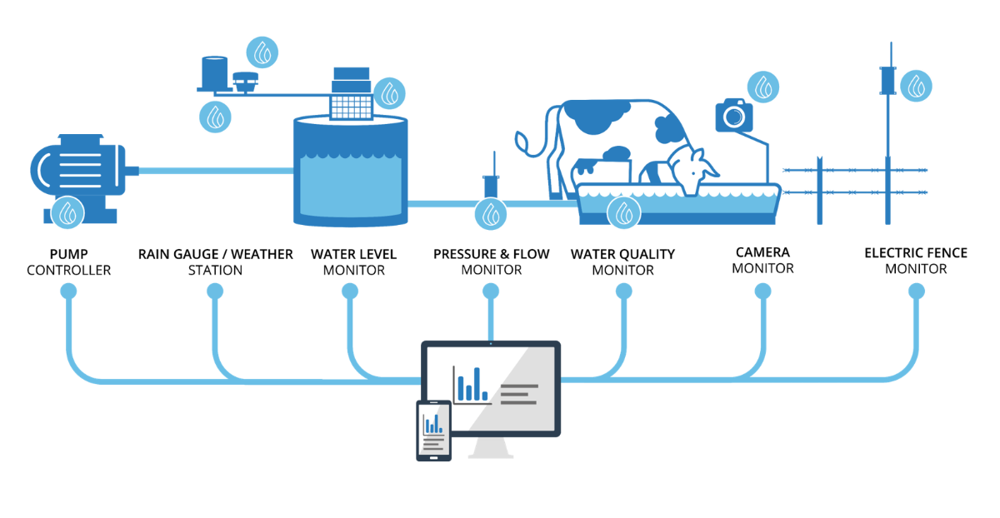

**Figure 13:** Emerging Ecosystem of monitoring products  
(Farmbot Monitoring Solutions, 2020)

Future research and development should be focused on highlighting more benefits of connectivity to build a better business case for producers to seek better services. Increasing the benefit as well as reducing the cost of connectivity increases the financial return for projects such as this and will be what drives the red meat industry forward into the phase of growth.

# Conclusion and Recommendations

## Conclusion

### 6.1.1 Initial Stage

The outcome of the initial stage was the successful installation of mobile sensing equipment at two trial sites on two different beef cattle properties. The installation of the equipment has seen a 50 to 60 percentage decrease in the need to visually inspect the areas in which the water monitors have been implemented. The commercial trials have demonstrated the data collection from the mobile sensing equipment at both properties. An evaluation framework has been set and the information is being collected both on farm and remotely. The short run time period has established that the mobile equipment to be operating without experiencing any downtime issues including no breaks in connectivity.

The primary learnings from the initial commissioning stage include:

* There is a large cost in visually checking waters as demonstrated in the evaluation methodology. There is also the added benefit of being able to divert resources to other jobs which is not considered in this evaluation.
* Remote water monitoring doesn’t completely alleviate the need to visually inspect watering points however it has reduced the need by up to 60% in some situations which is especially important during dry times when there is added pressure on infrastructure.
* Care is to be taken in interpretation of camera images. While the photo from the cameras does give a good snapshot in time, it does not provide the whole picture.

At the conclusion of the preliminary commercial trial, Stanbroke has collected valuable data on the costings and time savings from the sensing devices. The outcomes of the project were used to demonstrate to Stanbroke how connectivity benefits can be demonstrated through a relatively small connectivity project.

Therefore, in this specific scenario the tank level monitor proved to be more useful as a remote monitoring device as it captures more data which in turns adds more value when used correctly. The reduced upfront cost also provides an economic benefit, the ability to have the satellite communications allows for use in remote areas, which has the greatest ability to save time and money. The practical application for industry is to convince producers to re-evaluate how they spend their time and provide an alternative or combined solution to driving around checking waters.

### 6.1.2 Final Stage

Following the completion of the project, the benefits of both systems have been easily identifiable over the trial period. Trial Site 2 has installed more devices to compliment the initial monitors that were used in the trial phase of the project as well as trialling another connection type in one paddock. Trial site 1 also received new monitors to add to the network of devices. There was a slight delay in the second wave of monitors, although they have now been installed and are operational. The updated device is predicted to have forward compatibility with other emerging technologies such as pump controllers and other sensing equipment. The manager at Trial Site 2 also predicts that when Flow monitors are installed along with the tank monitors the bore run could be reduced to once per week. It is also confirmed that the new devices have the ability to connect to multiple sensors with both Trial site 1 and 2 receiving devices that can track water levels, flow rates and rain fall. Managers from other properties have also requested remote sensing infrastructure be installed on their own stations. It has been proposed that the stations with the longest and least accessible bore runs be the focus of the next trial site. As part of planning process for the 2021 season each station is working on the most effective position for their own first wave on devices.

## 6.2 Recommendations

The successful completion of the short run trial to evaluate the sensing equipment in on-farm applications (over two trial properties over a range of scenarios) involved running trials to collect and analyse data including camera images over a six-month period. At the conclusion of the detailed trial period, a preliminary report on the evaluation of sensing equipment and field-testing in various on-farm applications was submitted to the project group for approval.

The next phase was a long run period two-year time trial of the mobile sensing equipment over the two properties continuing with the two systems. At the first monitoring and review point (i.e. three months into the 2-year period), the combined solution using both devices demonstrated production efficiencies and labour savings to the business by reducing the time spent routinely checking watering points and better utilisation of labour across the business. Furthermore, the data collected was used to improve water management practices across the properties by evaluating stock watering usage rates real time against rainfall. The benefits to the beef production operation were evaluated as part of the long run trial period. At the conclusion of the project the wider industry benefit has been realised after being evaluated over several commercial scenarios at large scale. On-farm sensing devices can have immediate improvements on multiple factors including improved labour allocation, decreased monitoring costs, new ability to prioritise repairs and maintenance, improved decision making, improved confidence in water security, access to previously unknown information (such as micro-climate rainfall) and improved visibility for property stakeholders.

It is recommended that further expansion of the current network of monitors is undertaken. This should include more of the same equipment (tank monitors and rain gauges), as well as new systems to work with the existing infrastructure. The long-term goal would be to have near-real time data on every major water point with the ability to remotely send a signal to the site (such as switching a pump on/off).

Future research and development should be focused on highlighting more benefits of connectivity to build a better business case for producers to seek better services. Increasing the benefit as well as reducing the cost of connectivity increases the financial return for projects such as this and will be what drives the red meat industry forward into the phase of growth.

After the initial adoption phase on the technology curve the property managers now see the real benefits of the remote monitoring equipment and would like to install devices on their own properties. Stanbroke has decided to further the trial and implement the technology across more locations first focusing on the waters which have the furthest distance to travel which will save the most time and kilometres travelled. Stanbroke is also investigating other connectivity solutions with the aim to further reduce the cost of the telecommunications component of the on-going cost.

# References

Farmbot Monitoring Solutions, 2020. *Farmbot Monitoring Solutions.* [Online]   
Available at: https://www.farmbot.com.au/solutions/  
[Accessed 25 July 2020].

Science Direct, 2019. *LoRa.* [Online]   
Available at: https://www.sciencedirect.com/topics/engineering/lora  
[Accessed 25 July 2020].

uSee Remote Monitoring, 2020. *uSee Remote Monitoring.* [Online]   
Available at: https://www.usee.com/sites  
[Accessed 25 July 2020].

Personal communications (pers comm. Stanbroke staff)

# Appendix

## 8.1 Farmbot Tank Monitor



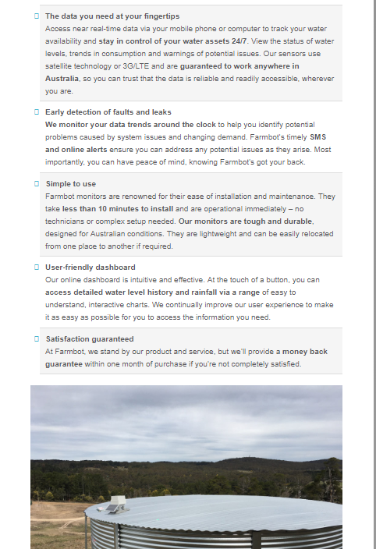

(Farmbot Monitoring Solutions, 2020)

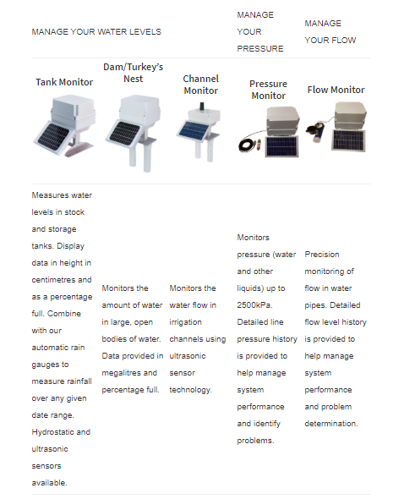

(Farmbot Monitoring Solutions, 2020)

## 8.2 uSee Camera Monitor

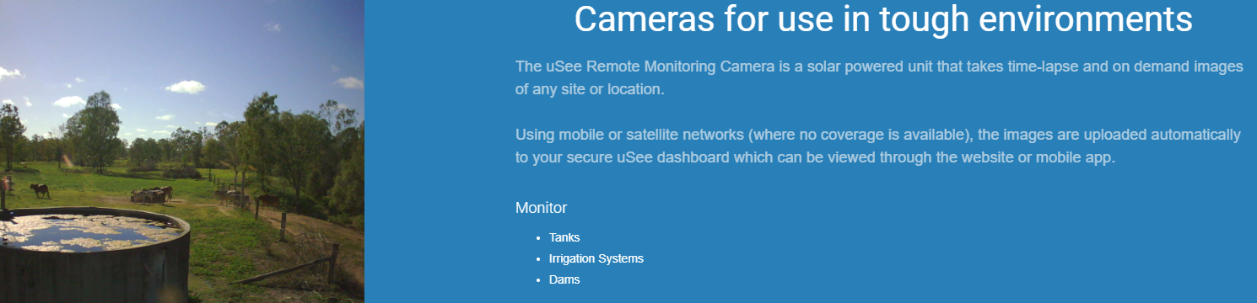

(uSee Remote Monitoring, 2020)

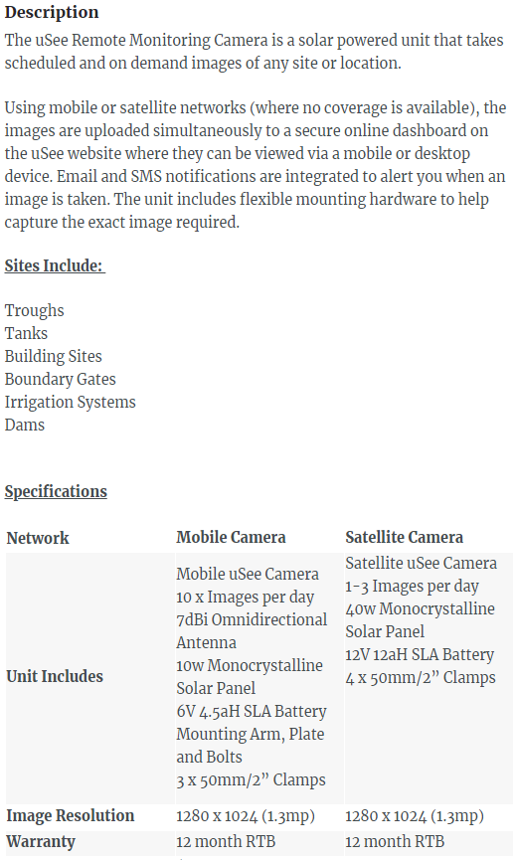

(uSee Remote Monitoring, 2020)