

**Expressions of Interest**

**Quarterly Call for Co-investment in Sustainability Projects – MLA Donor Company**

**Summary**

The Sustainability (On Farm) program invests in research, development and adoption activities to foster the natural capital base, improve grazing land stewardship and resource use intensity with beneficial impacts on global climate, food security and farm profitability. The program also assists the supply chain on emerging sustainability requirements, opportunities and frameworks.

This includes a focus on farming system efficiency to lower operational costs, income diversification opportunities, and improvements of the natural capital base that improves capital asset value.

Meat & Livestock Australia (MLA) via the MLA Donor Company is seeking expressions of interest from organisations (or partnerships of organisations) to co-invest with MLA in research for the following areas:

* Biogenic carbon cycle program - building the complete farm system carbon cycle including low-cost approaches to model carbon sequestration/fluxes
* Efficiency solutions that improve operational cost and resource use intensity
* Novel land development or management strategies for climate resilience that improve capital asset value and/or operational cost and environmental outcomes

The program prioritises opportunities that reduce the timeframe to adoption with maximum attributable environmental and profitability outcomes for Australian red meat producers.

**Background**

***Biogenic carbon cycle program – building the complete farm system carbon cycle***

Grazing livestock are part of a whole farm system and carbon cycle. Net greenhouse gas emissions of the grazing system is the balance between the **emissions** (from livestock, lime application, fertiliser, pasture residues, vegetation or soil carbon loss due to conversion or management of grazing land) and **sequestration** in the farming environment (soils and vegetation). Establishing a net emissions position versus a direct emission position acknowledges the role grazing livestock have in the environment and the biogenic nature of ruminant derived greenhouse gas.

At a farm systems level there are other parts of the carbon cycle that may be able to be incorporated into emissions and sequestration calculations, but further R&D is required to establish measurement technology and frameworks for adequate calculation of these fluxes.

Currently, an unaccounted pool is the annual change in above and below ground carbon stocks of perennial pastures. The Australian National Inventory report (2022) currently assumes an IPCC Tier 1 approach to grassland above and below ground biomass (no net gain or loss), despite soil carbon changes being modelled under grasslands. The IPCC (2006) Guidelines in Section 6.2.1 (Grassland Remaining Grassland - Biomass), discusses allowance for use of Tier 2 & Tier 3 approaches for estimations of changing carbon stocks in grassland where management changes are occurring over time (e.g. through introductions of silvopastoral systems, tree/brush removal for grazing management, improved pasture management or other practices), to account for potentially significant carbon stock changes. The IPCC (2006) states it is *good practice* for countries to strive to improve inventory and reporting approaches by advancing to the highest tier possible given national circumstances.

To enable a framework for inclusion of Biomass in the National Inventory will rely on establishment of measurement technology that can precisely and accurately measure forage across diverse pastures in Australia at an affordable cost.

The flux of methane into soil (by methanotrophic bacteria) and out of soil (under anaerobic conditions) remains to be studied at scale across the diverse grazing lands of Australia. Global methane budgets published in IPCC AR6 Chapter 5 globally indicates soil uptake of methane between 2008-17 of between 30-37 Tg CH4/yr, while enteric methane and manure emissions are reported at 109 Tg CH4/yr. Further research is needed to understand how methane flux on grazing land occurs across different soils and rainfalls and if human management can influence its flux (e.g. grazing in wetlands, or stocking rate).

Finally, an atmospheric nitrogen cycle also exists, albeit across much longer timeframe, and the roles of legumes, biocrusts, soil types and rainfall in soil nitrogen flux over diverse landscapes requires further research.

MLA continues to invest and support development of soil carbon and vegetation sequestration models. Low-cost methods are required that can predict changes in these carbon pools and fluxes (soil, woody vegetation, pasture biomass) across diverse grazing environments with evaluation of their accuracy and precision relative to current gold standards for measurement.

***Efficiency solutions***

Australian producers have the opportunity through best practice management to improve livestock resource use efficiency. Efficiency is directly linked to cost of gain and profitability.

There are many resource use efficiency drivers on farm which may increase weight-for-age, reduce the proportion of unproductive animals, or change the ratio of livestock classes on farm to be more efficient. These include but are not limited to correct calving/lambing time to match feed availability, watering point distribution to manage pasture utilisation and walking distance, appropriate weaning times for environment, genetics for growth and fertility, ionophore or science-based additive use, health management (parasites, viruses, bacteria), strategic supplementation of (energy, mineral and protein), lot feeding and effective hormonal growth promotant (HGP) use.

In addition, novel feed additives and vaccination approaches are evolving to capture energy loss from rumen fermentation (e.g. methane can represent a loss of 6 to 8% of gross energy intake). Continued research into the rumen microbiome and optimising grazing supplement return on investment remains a priority.

MLA is calling for expressions to identify novel ways to accelerate efficiency gains to the Australian industry.

***Novel land development or management strategies for climate resilience that improve capital asset value and/or operational cost and environmental outcomes***

Australian producers are stewards of over 50% of Australia’s land mass, which operate in an increasingly variable climate. To become resilient in this variable climate requires sustainable access to adequate forage and water to promote livestock growth and reproduction and optimise supplementation costs.

Water security and quality is critical for both livestock requirements and environmental flows into the surrounding catchment basins. Strategies for dam and permanent watering point design, ground cover retention and watercourse protection to promote water quality and security are an ongoing opportunity.

Sustainable access to forage relies on the appropriate soil quality, pasture composition, fire, weed, vegetation and total grazing pressure management.

Improved pastures and legumes have also been planted across many regions of Australia. Through ongoing development and management practices, business owners can influence the hydrology of the landscape, the structure and water holding capacity of soils. Fencing for many years has for many years for grazing management and newer remote virtual fencing technologies are evolving.

Decision support tools (satellite and weather forecasting) are evolving to support management of total grazing pressure and balance the economic and environmental outcomes of over or under stocking. In addition, forage conservation methods and confinement feeding of stock are important climate risk management options with environmental co-benefits.

Vegetation management of regrowth and invasive weeds is also a high priority in many regions. Beneficial vegetation in the form of shelter belts, watercourse protection and timber production are also an area of interest. Management of invasive pests is critical to maintain desirable forage yield, and reduce total grazing pressure, soil conservation and water quality. Fire management is an important aspect of sustainability on rural properties with flexible strategies required due to the diversity of ecosystems across grazing regions.

MLA seeks partnerships for novel development or management strategies that can be deployed at scale with measurable impacts on property capital value, operational costs and environmental outcomes.



**Expressions of Interest**

**Quarterly Call for Co-investment in Sustainability Projects – MLA Donor Company**

**Please register what project area you are expressing interesting in:**

Biogenic carbon cycle program - methane and nitrous oxide flux in soils

Biogenic carbon cycle program - forage biomass changes

Biogenic carbon cycle program – woody vegetation modelling

Biogenic carbon cycle program – soil carbon modelling

Efficiency solutions that improve operational cost and resource use intensity

Novel land development or management strategies for climate resilience that improve capital asset value and/or operational cost and environmental outcomes

**Business Name**

|  |  |
| --- | --- |
| **Name** |  |
| **ABN** |  |
| **Street Address** |  |
| **Postal Address** |  |

**Name of Applicant**

|  |  |
| --- | --- |
| **Name** |  |
| **Mailing Address** |  |
| **Phone Number** |  |
| **Email Address** |  |

**Background & Activities Proposed**

*In less than 1 page explain the background and proposed activities proposed*

**Objectives**

*Outline the projects objectives. Use verbs when starting objectives e.g. Determine, Develop, Evaluate*

**Technology readiness level**

*Outline the Technology readiness level of your solution/opportunity. See Table of TRL 1 to 9 in Appendix.*

**Timeframe**

*Outline the development cycle and timeframe to commercial adoption. Use items such as tables or Gantt charts to demonstrate.*

**Cost and Benefit**

*Outline the projected cost of the technology or model at market adoption, along financial beneficial benefits (e.g. ROI, Net Present value, payback periods).*

**Unique selling proposition**

*What makes your proposed offering unique and why would producers want to adopt it?*

**Adoption Pathways**

*Outline the current level of adoption and total addressable market (producers or hectares). Outline the potential serviceable market, who are the competitors in the market, and the likely obtainable market (producers or hectares). What are the existing or proposed commercial pathways for adoption? Please see appendix for definitions of addressable, serviceable and obtainable markets.*

**Safety or Regulatory Issues**

*Outline any expected safety or regulatory issues*

**Indicative Budget**

Outline a total indicative budget for fees, expenses and capital for the project (AUD, Excl. GST).

**Confidentiality**

By submitting an expression of interest, the applicant will disclose information in the expressions of interest form to MLA’s employees, agents, contractors and advisors, for the purposes of the expressions of interest process and any legal or MLA policy requirement. Applicants must identify any information that they consider should be protected as confidential information and provide reasons for this. Confidential IP should not be divulged by the applicant as part of the expressions of interest process.

**Process**

MLA will review the expression of interest. Proposals will be ranked on expected techno-economic feasibility including timeframe to commercial adoption and obtainable impact change. MLA will contact parties to indicate if their expression of interest has been prioritized.

**Project proposal submissions:**

The expressions of interest form contained in this document must be lodged electronically as Word document to: [tenders@mla.com.au](mailto:tenders@mla.com.au)

Expressions of interest must be received by 1700 AEST on Thursday 19th June.

Strict adherence to the time deadline for applications will occur.

**Further information:**

Dr. John Bennett

Program Manager – Sustainability R&D

**P**: +61 (7) 3620 5274  **M**: +61 0428 060 902

jbennett@mla.com.au

Research & Development

Meat & Livestock Australia

**Authorised Person (Signatory) In submitting this form, I warrant:**

(a) I have the authorisation to make this warranty on behalf of the Applicant Organisation.

(b) that the information in this application is accurate, and the project will be performed in accordance with all statutory, professional and ethical standards and practices.

(c) in relation to any personal information provided to MLA in this application, before providing any personal information to MLA, notified all individuals to whom the personal information relates that it will be disclosing their personal information to MLA for the purposes of this application/ the project and obtained any required consent to such disclosure; and (ii) provided those individuals with information about where they may find [MLA's Privacy policy.](https://www.mla.com.au/general/privacy/)

Name:

Title:

Signature:

Date:

**Appendix**

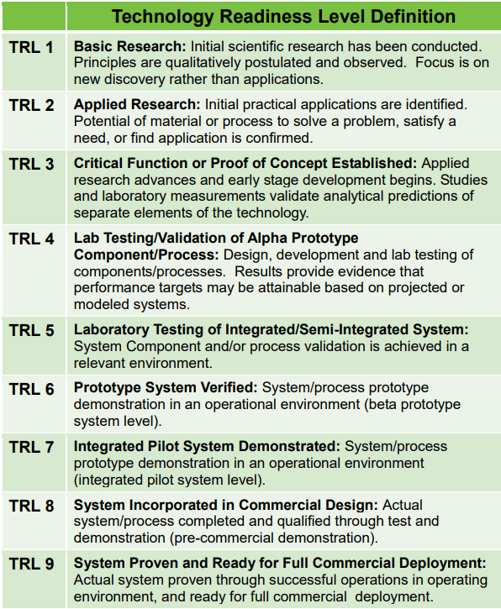

**Market Size Definitions**

Total addressable market represents the number of producers, hectares or revenue for an opportunity that could be solved by a R&D solution.

The total serviceable market is the portion of the addressable market that could be serviced considering factors like geographic reach and distribution.

The total obtainable market is the proportion of the serviceable market that you can realistically capture and will actually adopt your R&D solution based on historical performance, awareness of your company or solution and competition.