Free membership for livestock producers
Free information for MLA members

To register as an MLA member, complete each step below.
MEMBERSHIP APPLICATION

Step 1 Write your name/s (individual producers and partnerships only)
Mr/Mrs/Ms/Other Name of applicant 1

Mr/Mrs/Ms/Other Name of joint applicant

Mr/Mrs/Ms/Other Name of joint applicant

Mr/Mrs/Ms/Other Name of joint applicant

Step 2 Write your company/trading name and ABN
Company name

Trading name

ABN Company ACN

Step 3 Write your contact details
Main contact person (if different from applicant 1 at step 1)

Address

Suburb/town State Post code

Postal address (if different)

Suburb/town State Post code

Telephone number Email address

Fax number Mobile telephone number

Step 4 What livestock do you produce?
Tick one or more boxes that relate to the class of livestock you produce. See over for eligibility criteria.

Cattle Grainfed cattle Sheep only Sheep and prime lamb Goats
In signing this form you agree that each applicant is a producer of at least one of the livestock categories above and has paid or will pay the Federal Government transaction levies during the current financial year or during either or both of the two preceding financial years. To the best of each applicant’s knowledge and belief, all statements in this application are correct. Each applicant agrees to be bound by the constitution of MLA.

Step 5 Sign this form Step 6 Return this form to MLA
Mail Meat & Livestock Australia Limited Reply Paid 3561, Melbourne VIC 8060
196657_01PC0B

Sign here
(no stamp required if posted in Australia)
Fax 1800 012 153
Phone 1800 550 060 for more information

MLA

INFORMATION FOR APPLICANTS

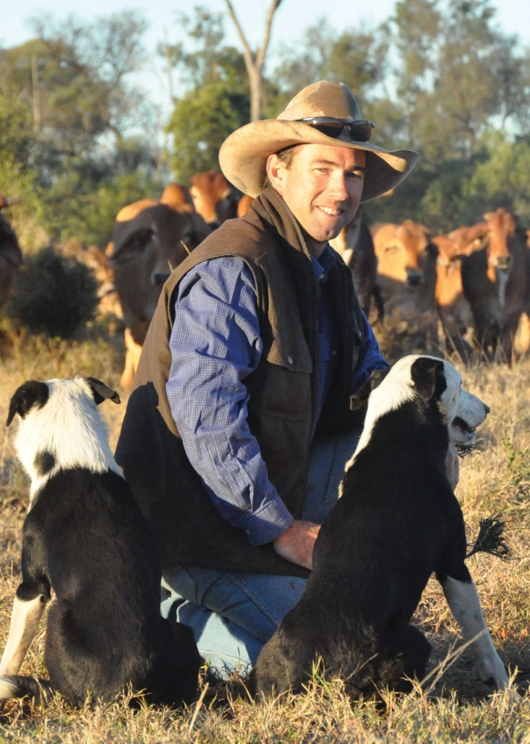
Eligibility
BECOME A MEMBER OF MLA
Members get it free or at a discount
- Feedback magazine – stories on your industry
in your mailbox six times a year
- Your choice of regular market reports and daily
(eastern states) and weekly (national) livestock indicator reports
- Publications for free or at a discounted price
- Weekly e-newsletter fridayfeedback with market
news, industry news and on-farm information
- Discounts to events throughout Australia
For more information call 1800 675 717 or visit
www.mla.com.au/membership
To be eligible as a member of Meat & Livestock Australia Limited ABN 39 081 678 364 (MLA), the applicant must:
- be a Producer; and
- pay Levies during the financial year in which an application for membership is made, or paid Levies during either or both of the two preceding financial years.
Producer means a person engaged in the raising, finishing or trading of livestock for production or for live export and includes a producer of cattle*, grainfed cattle*, sheep (including lambs) and goats.
*cattle means bovine animals other than buffaloes and includes calves but excludes grainfed cattle;
*grainfed cattle means grainfed cattle that are eligible for GF or GFYG certification or third party audited certification approved by AUS-MEAT attesting that cattle are being fed to at least the AUS-MEAT minimum standards for grainfed beef.
Levies means levies or charges imposed on producers of livestock under the following Acts:
- the Primary Industries (Customs) Charges Act 1999; and
- the Primary Industries (Excise) Levies Act 1999.

MLA Constitution
Copies of MLA’s constitution are available on MLA’s website at www.mla.com.au or by request.

MLA privacy notice
The information you are providing to Meat & Livestock Australia Limited (MLA) may be personal information under the Privacy Act. We will collect, hold, use and disclose the email address and the personal information you provide in the manner set out in MLA’s privacy policy which can be viewed at www.mla.com.au/general/privacy or obtained directly from MLA by calling 1800 675 717. By providing MLA with your personal information, you consent to the collection and handling of your personal information in accordance with MLA’s privacy policy. You may access and correct any personal information held by MLA
196657_01PC0B
on request.

The personal information held by MLA will be used to keep you informed about member benefits, market news, industry information and other communications from MLA. If you provide a telephone number, you consent to MLA contacting you for an indefinite period about future products and services that may be of interest to you. If you do not provide the personal information requested, MLA may not be able to provide you with products or services.

