Quality Policy
Our Quality Policy is driven by following management principles and behaviors.

Meat Standards Australia (MSA) is committed to –

- delivering a world leading, consumer focussed, eating quality prediction program that improves the demand for and eating quality of Australian beef

- increasing global demand for Australian lamb & sheepmeat by ensuring consistent product performance and predictable cooked meal outcomes to exceed consumer expectations

We strive to provide consistent and accurate information on the eating quality of beef, lamb & sheepmeat to aid in the adoption, and awareness of MSA throughout the supply chain.

Our senior management and the MSA team are committed to maintaining a Quality Management System, which not only satisfies the needs of our customers and stakeholders but assists to develop staff competencies, creativity, empowerment and accountability

Through industry consultation we will continual review the MSA Program to identify opportunities for improvement and to ensure we maintain effective, internal and external communication.

The Quality Policy and Management System is implemented through active involvement of the entire MSA team for compliance to AS/NZS ISO 9001:2015 Quality Management System Requirements and USDA Process Verified Program PVP 1001 Procedure. As a team we are dedicated to the continuous improvement of our Quality Management System.

Regularly reviewing our quality objectives allows us to establish and maintain an effective and efficient quality system.

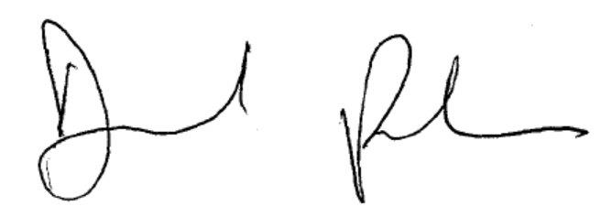

David Packer
Program Manager Meat Standards Australia
10th March 2021

