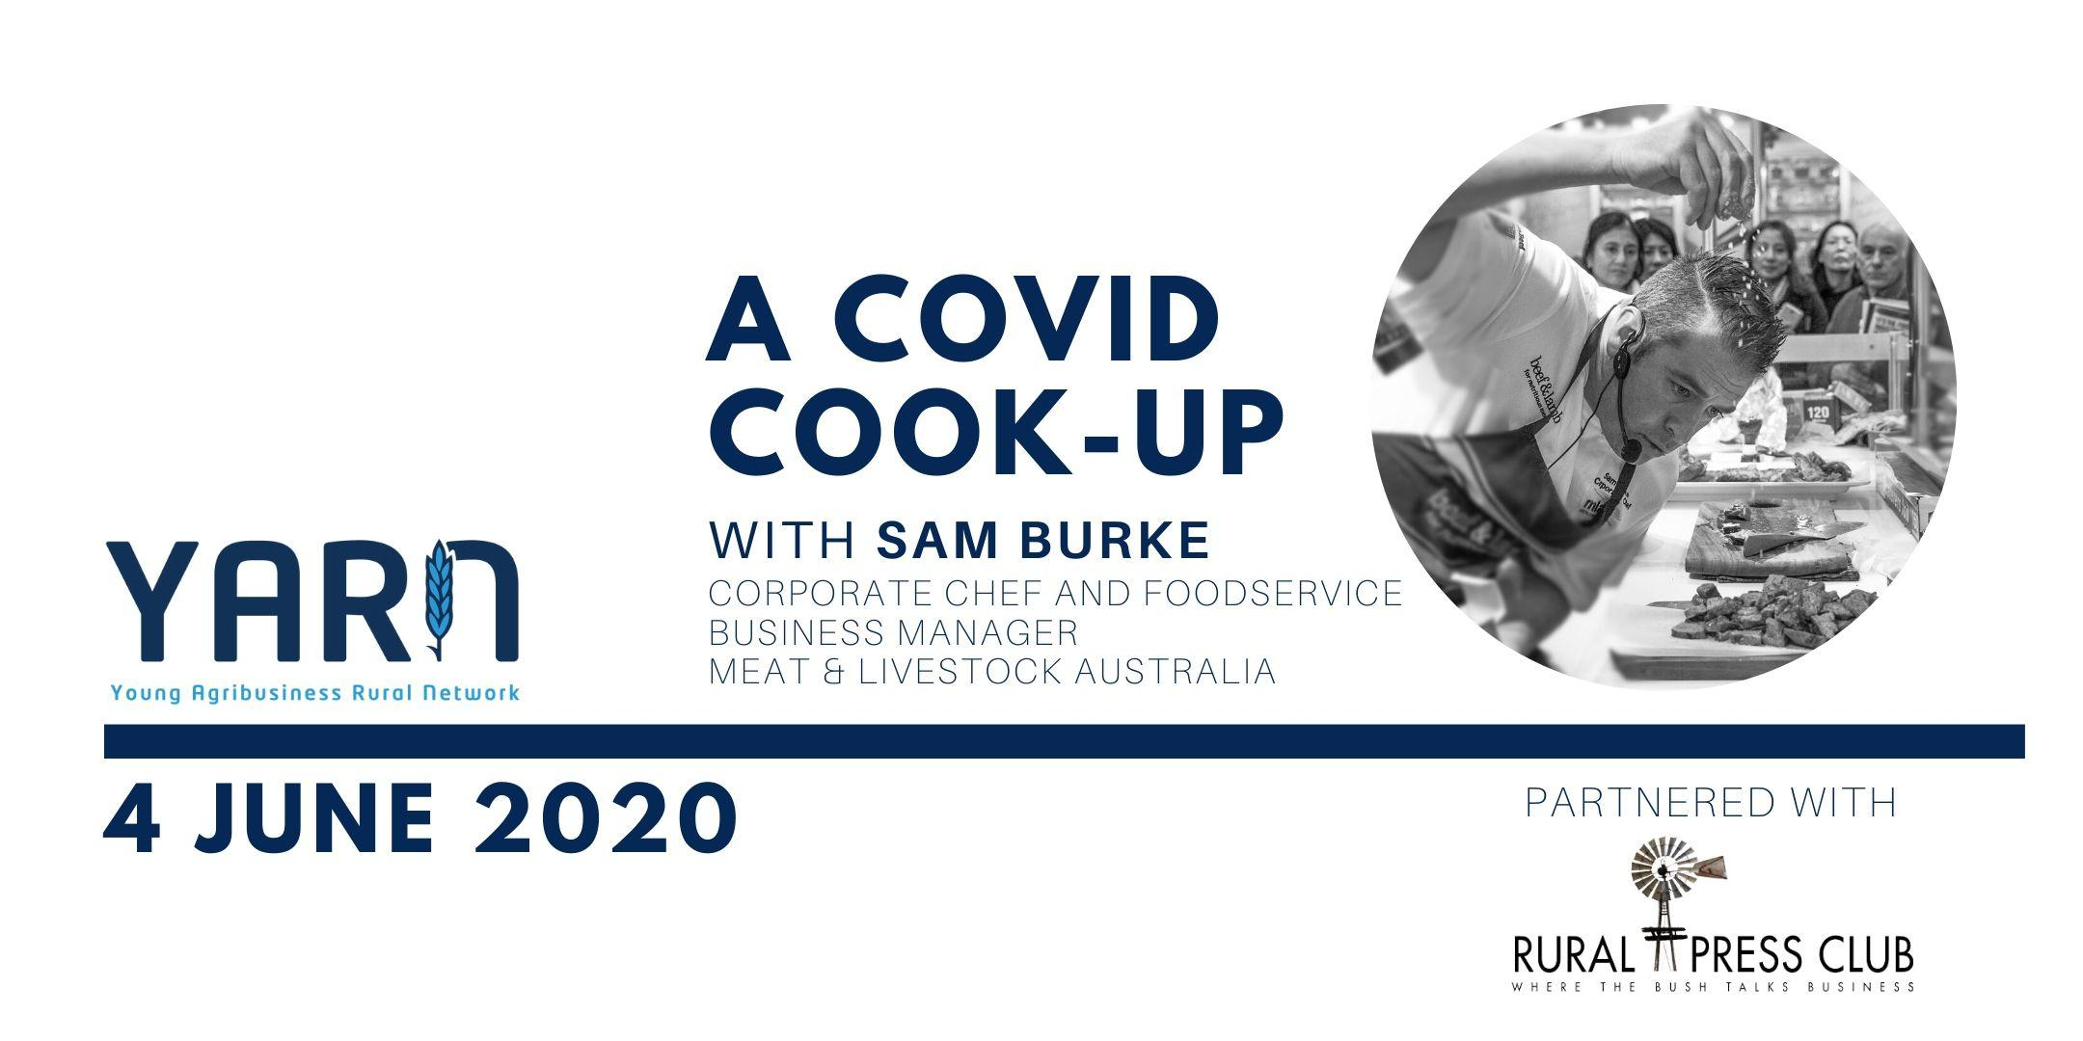

YARN is excited to be partnering with the Queensland Rural Press Club to bring Meat and Livestock Australia’s Sam Burke to your kitchen for a COVID Cook-Up.

The COVID-19 pandemic has provided many challenges for most of us these past few months, including making the usual YARN event format impossible. On the flip side, it has also given us a chance to get back to basics, including honing in on our cooking skills. With cuts of meat we’d never dream of cooking at home now available on supermarket shelves, we think it’s time to kick it up a notch from banana bread and sourdough!

And who better to show us the way than Sam Burke?

Corporate Chef and Foodservice Business Manager, Sam Burke joined Meat & Livestock Australia (MLA) in 2014 and has since travelled across Australia and the globe promoting and celebrating the quality and diversity of premium Australian red meat.

Inspiring audiences to think about meat in a way they never had before, Sam acts as the critical link between the Australian red meat industry and some of its most important consumers.

Sam’s expertise in large scale catering environments has enabled him to educate Australian Red Meat users on plate costs, product development and extracting value from the whole carcase.

This included working with McDonald's Japan on new sandwich concepts using Australian red meat alongside their traditional burger offerings and enabling other quick service restaurants and retailers to present smaller primal cuts to suit the growing convenience trend.

Sam will create a menu for attendees to cook along at home, while sharing insights into the red meat industry, as well as some stories from his travels around the world.

As restrictions begin to ease, we encourage you to get together a few of your friends and join us in our COVID Cook Up with Sam Burke!

Event Details
When: 6pm, Thursday 4 June 2020
Partnered with: Rural Press Club Queensland
Chef: Sam Burke, Corporate Chef and Foodservice Business Manager
Cost: Free, however, registration is required

About Sam Burke
Starting out as an apprentice chef Sam worked his way up the catering trade in butcher shops, corporate, leisure and sporting events including the Olympics and Rugby World Cup, before joining one of Australia’s largest commercial catering companies for 20 years.

Trading catering halls for beef and boardrooms, Sam took over the executive chef reins at Meat & Livestock Australia (MLA) in 2014 and has since travelled across Australia and the globe promoting and celebrating the quality and diversity of premium Australian red meat to the wider community.

Globally, Sam has cooked for thousands ranging from trade shows in Asia, wagyu experts in Japan, politicians, sports stars, musicians in Australia and most recently at the Queen’s Young Achievers annual celebration at the Australian High Commission in London.

The Young Agribusiness Rural Network was founded with a goal to foster an emerging agribusiness professional community in Brisbane. Normally, our quarterly network events aim to provide an opportunity for young professionals working in, or adjacent to, the agribusiness industry to network with one another and rub shoulders with industry leaders. Our chosen keynote speakers will provide insights into a career in agriculture, as well as sharing their perspective on current challenges facing the industry.

Follow YARN on Facebook and LinkedIn.

