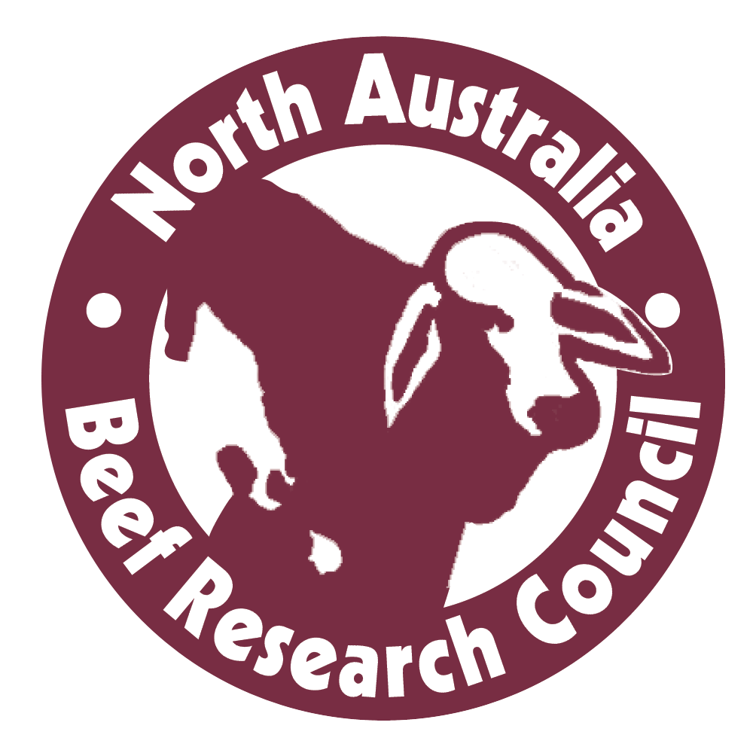 | APPLICATION  Funding support to attend  Northern Beef Research Update Conference (NBRUC)  19-22 August 2019, Brisbane
Are you a beef producer in northern Australia?
Would you like to receive a complimentary full registration to attend NBRUC?
If so, you are invited to submit an application to be considered to receive a free registration (including all social events and a field trip of your choice) to attend the Northern Beef Research Update Conference that is being held from 19-22 August 2019 at the Brisbane Convention and Entertainment Centre. More information about NBRUC is available at:
https://www.nbruc2019.com/
Please note: If you have received funding support from NABRC to attend a previous NBRUC, you are not eligible to apply for funding support to attend the 2019 conference.

Name
Address

Email address
Phone
Present occupation
Summarise your commitment to and achievements in the north Australia beef industry
(in 200 words or less).

How will your participation in the conference help your to contribution to your business and the north Australian beef industry
(in 200 words or less).

Send your completed application to
Jackie Kyte – jackie@jackiekyte.com.au - by Wednesday 10 July 2019
Any queries please phone Jackie on 0409 564 729
Successful applicants will be advised by Monday 22 July 2019.

