



**Stawell Town Hall**

**Monday 27 March 2017**

**4 – 8.30 pm**

|  |  |
| --- | --- |
| ***Setting the scene for 2017***  **Perennial Pasture Systems and the Grasslands Society of Southern Australia are bringing together a range of selected speakers to present up to date research topics at an MLA Pasture update**  **two GrasslandSociety_Logo_Lg.jpg** | |
| **Speaker** | **Topics** |
| Andrew Speirs; Meridian Ag | Nutrient replacement after a wet year |
| Nathan Scott; Achieve Ag | Autumn feed quality – how to reduce carryover feed & maintain stock condition |
| Alison Frischke; Birchip Cropping Group | Grazing cereals in the Southern Wimmera and Central District |
| Rachael Campbell; Agriculture Victoria | PPS/MLA EPDS gibberellic acid demonstration results 2016 |
| Ben Thomas; Manager Market Information and National Livestock Reporting Service | Livestock market update and what to expect for the year ahead |
| Irene Sobotta; MLA Innovation & Adoption Project Manager – Sustainable Feedbase | MLA feedbase RD&E investments |
|  |  |

****

**Registration form Registrations by 25 March**

Company name: ………………………………………………………………………………………………………………………………………………………………..

Name:

Postal address:

Postcode:

Phone: Mobile: Fax:

Email address:

Special dietary requirements: ……………………………………………………………………………………………………………………………………………

|  |  |
| --- | --- |
| **DIRECT DEPOSIT** | **CREDIT CARD** |
| (please email office@grasslands.org.au with your details if paying by direct deposit) | Please deduct my credit card for $ \_\_\_\_\_\_\_\_\_\_\_\_\_\_\_\_\_\_\_\_\_\_\_ |
| BANK: Bendigo Bank | Mastercard Visa |
| ACCOUNT NAME: GSSA  BSB: 633-000 Account:1431 87599 | Credit Card Number  \_\_ \_\_ \_\_ \_\_ / \_\_ \_\_ \_\_ \_\_ / \_\_ \_\_ \_\_ \_\_ / \_\_ \_\_ \_\_ \_\_ |
| Reference: ‘Surname’ then ‘Stawell PU’ | Expiry \_\_ \_\_ / \_\_ \_\_ |
| **CHEQUE** **MONEY ORDER** | Name on card: |
|  | Signature: |

**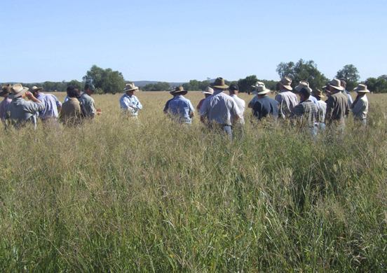Time:** 4.00pm – 8.30pm

**Venue:** Stawell Town Hall, Main St, Stawell

**Admission:** $20.00: Includes light supper and afternoon tea

**RSVP:** Friday 25 March 2017 to

GSSA Secretary Melinda Caspersz 1300 137550 office@grasslands.org .au

or PPS Project Manager Rob Shea 0438 521357 yadin@netconnect.com.au

**Further Information:** Contact PPS Project Manager Rob Shea 0438 521357

**Registration:** Complete the registration form and send as per contact details or submit with payment on the day; Eftpos available.

**This Pasture update is delivered in conjunction with:**

   

Contact PPS Project Manager Rob Shea 0438 521357