**ParaBoss webinar: Gaining the upper hand on sheep blowflies – this season and into the future**

* Date and Time: Tuesday, 18 October 2022 1:00 pm AEST.
* Presenter: Megan Rogers, Megan Rogers Consulting Pty Ltd
* Host: Dr Fiona Macarthur, ParaBoss

ParaBoss external partner’s link: <https://us06web.zoom.us/webinar/register/5116635557064/WN_T8DWxTmBTAyB16XrJyttEg>

**Hero image**

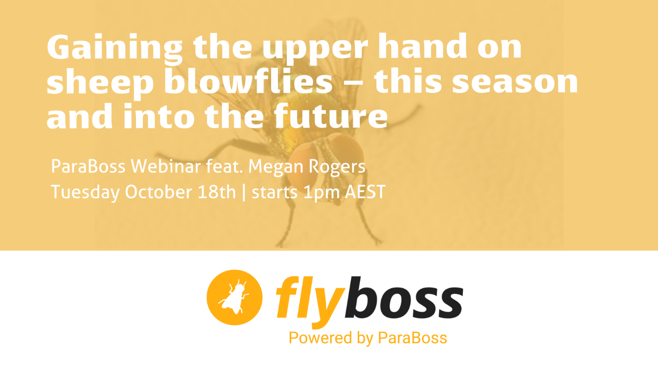

**e-newsletter or website blurb**

New ParaBoss webinar: Gaining the upper hand on sheep blowflies – this season and into the future.

Gaining an upper hand on sheep blowflies takes both a tactical (short-term) and a strategic (long-term) approach.

The focus of this webinar will be two of the workshops that are part of the Australian Wool Innovation (AWI) developed flystrike extension program – SimpliFly™ – strategic planning and management of flystrike and ClassiFly™ – breeding for improved flystrike resistance.

In this ParaBoss webinar, join Megan Rogers, who will provide an update on some of the key content from these workshops to help you gain an insight into a number of the tools and strategies that you can use in the short and longer term to help with your flock.

As always, we encourage you to send in any questions to [extension@paraboss.com.au](mailto:extension@paraboss.com.au) or ask them real time in the webinar!

Register today.

<use link <https://us06web.zoom.us/webinar/register/1916635556604/WN_T8DWxTmBTAyB16XrJyttEg>>

**Facebook / LinkedIn**

Gaining an upper hand on sheep blowflies takes both a tactical (short-term) and a strategic (long-term) approach. Join the ParaBoss team for a new webinar on effective management of blowflies in sheep!

Register here: <https://us06web.zoom.us/webinar/register/1916635556604/WN_T8DWxTmBTAyB16XrJyttEg>

The focus of this webinar will be two of the workshops that are part of the Australian Wool Innovation (AWI) developed flystrike extension program – SimpliFly™ – strategic planning and management of flystrike and ClassiFly™ – breeding for improved flystrike resistance.

Join along with Megan Rogers, who will provide an update on some of the key content from these workshops to help you gain an insight into a number of the tools and strategies that you can use in the short and longer term to help with your flock.

As always, we encourage you to send in any questions to [extension@paraboss.com.au](mailto:extension@paraboss.com.au) or ask them real time in the webinar!

Can’t make it? The webinar will be recorded and made available for viewing on the ParaBoss YouTube channel!

#flystrike #ParaBoss #sheepblowflies #sheepwebinar #sheep #livestock #animalhealth #parasite

<tag relevant organisations>

<insert hero image>

**Tweet**

#ParaBoss webinar: Gaining the upper hand on sheep blowflies – this season and into the future! Register 👉 <https://us06web.zoom.us/webinar/register/1916635556604/WN_T8DWxTmBTAyB16XrJyttEg>

Featuring Megan Rogers, who will help you gain an insight into a number of the tools and strategies that you can use in the short and longer term to gain an upper hand on sheep blowflies in your flock.

<insert hero image>

**Additional text**

If space allows you are also welcome to note this footer text:

*ParaBoss – paraboss.com.au - is a joint initiative between Meat and Livestock Australia, Australian Wool Innovation, University of New England and Animal Health Australia*