**Expressions of Interest**

**Southern Rangelands Practice Change**

Meat & Livestock Australia (MLA) are seeking partnerships to co-design a producer adoption program, targeted at the Australian Southern Rangelands. The broad intention of this project will be to improve business productivity, profitability and sustainability. To achieve this, expressions of interest (EOI) are invited from all industry stakeholders, including but not limited to supply chains (processors/brand owners), producers, industry organisations, research bodies and advisors. By partnering with MLA there is an opportunity to expand reach and resources to maximise the impact of producer engagement activities and long-term improvement.

The below figure indicates the general extent of the southern rangelands, relative to research council boundaries. The southern rangelands experiences challenges of isolation, expansive areas, sparse populations and unique environments, which require a customised approach to extension and adoption activities. Through this EOI, we hope to identify opportunities to pursue in this area.

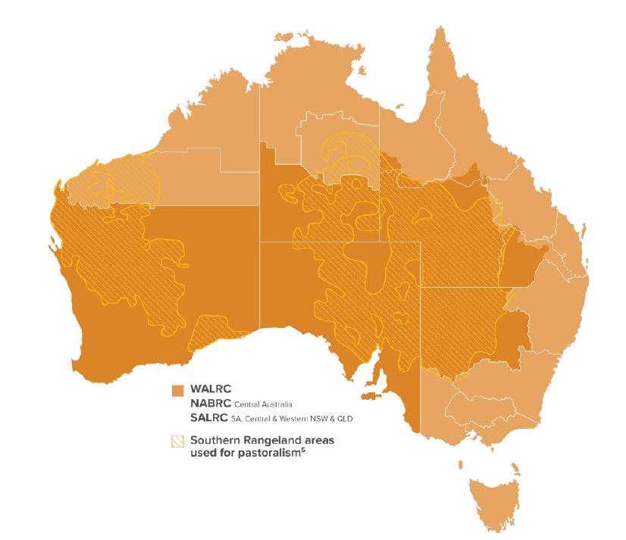

Figure 1. Southern rangelands (Hacker et al 2019a).

**Aim**

Develop and implement a long-term practice change program that employs peer-to-peer learning methods, focused on supporting producers in optimising productivity and profitability.

Through engagement with industry service providers, knowledge, skills and confidence will be increased in any or all of the below technical areas:

* Reproductive efficiency
* Land management
* Marketing and meeting market specifications
* Livestock management (health, nutrition, husbandry)
* Livestock breeding and genetics

This will ultimately result in measurable practice change.

This will be a customised adoption program, designed to fit the needs of a specific producer group and/or value chain where existing off-the-shelf adoption products do not sufficiently meet industry needs. In order to meet this, behavioural science principles should be included to inform project activities. The opportunity also exists to gain greater knowledge of behavioural science drivers relevant to the region, as part of the project.

As part of the proposal, please identify the region and particular focus areas being addressed.

**What to expect**

As a co-design partner, MLA will:

* Provide up to 40% co-funding of the project
* Contribute to identifying focus topics, regions and producers to be involved
* Contribute to the project design and adoption methodologies
* Provide any linkages to existing adoption products to be incorporated within the project
* Ensure that a robust monitoring and evaluation framework is in place to measure knowledge change, adoption, practice change and impact

**Project Objectives**

Project objectives and activities can be proposed to meet specific project needs. As an example, project objectives might include:

1. *A network of producer groups is established focusing on best practice livestock management to improve animal productivity and land condition.*

*Activities may include:*

1. *Reproduction rate targets set*
2. *Complete relevant technical training*
3. *Implement livestock recording practices to measure performance*
4. *Coaching, advisory and peer support to implement technical knowledge*
5. *Reproductive efficiency is improved by 10% among project participants*

*Activities may include:*

1. *Implement pregnancy testing*
2. *Cull empty animals*
3. *Preferentially manage nutritional requirements of pregnant animals*
4. *Stocking rate is matched to long-term carrying capacity*

*Activities may include:*

1. *Carrying capacity assessed based on grazeable area, land condition and land type.*
2. *Stocking rate assessed based on total grazing pressure (domestic livestock plus unmanaged grazing animals).*
3. *Identification and culling of empty breeders to aid potential stocking rate reduction, while increased reproduction rate maintains productivity and profitability.*
4. *Priority plant species are identified and appropriate management implemented*
5. *Improve the knowledge, attitude, skills, and aspirations (KASA) of at least 80% of producers engaged in the supported learning program and ensure that at least 75% of participants implement the practices learned as part of the project.*

*Activities may include:*

1. *Participant entry and exit surveys*
2. *Participant evaluation of project activities*
3. *Benchmarking of performance in focus areas*

**Project Partners**

Examples of potential project partners are outlined below, noting that this table is by no means exhaustive.

|  |  |  |  |
| --- | --- | --- | --- |
| **Partners** | **Why we need you** | **What is the benefit** | **What we expect** |
| **Producers** | Value creation in the red meat sector starts with the animal on-farm. | Improve business performance through production efficiency, meeting market specifications and building supply chain networks. | Collect and share data and insights.  Commitment to project requirements and willingness to learn and adopt practices  MDC co investment partner. |
| **Livestock advisors including buyers, agents and consultants** | Provide expertise in a range of livestock supply chain areas across a range of regions and platforms. Trusted sources of advice to producers in regional areas.  Participation in the project as an upskilling opportunity. | Gain new networks and industry insights while providing a professional service | Collect and share data and insights  Commitment to impartial delivery of technical content.  MDC co investment partner. |
| **Processors, brand owners, retailers** | Strong producer relationships to engaged suppliers, with ability to influence change.  Adoption of objective measurement technologies to inform required on-farm practice change.  Source of customer insights to inform appropriate market signals. | Ability to influence producer practice change to increase compliance and the quality and consistency of supply. | Provision of carcase data and feedback.  Collaboration with producers to achieve mutually beneficial outcomes.  MDC co investment partner |
| **Other interested parties** | This could include Research & Development Corporations, Drought Hubs, NRM groups, government departments, animal health companies, breed societies, software and agtech providers, amongst others who might consider can assist in the design and delivery of work and funding activities related to on-farm practice change. | | |

**Project Timeframe**

It is suggested that any program would be established for at least four years to enable practice changes to be implemented and benefits to be realised.

**Funding**

This expression of interest is to identify opportunities for funding through the MLA Donor Company (MDC). Via MDC the Participant (Applicant) may be eligible to partner with MLA to receive a maximum of 40% project contribution. Optionally, this may be supplemented by other funding e.g. producer contributions to attend workshops.

All partners will need to agree to MLA's [Umbrella Research agreements](https://www.mla.com.au/about-mla/mla-agreements/) and project(s) will be contracted under the standard Terms and Conditions of the MLA Donor Company. This includes:

* The MDC’s statutory requirement for industry partners to provide matching financial contributions to the project(s).
* The production of a comprehensive Final Report which captures lessons learnt, challenges encountered and solutions identified to improve opportunities for future adopters.

Further information on the MDC program, including background and application guidelines is available at [Project application guidelines and forms | Meat & Livestock Australia](https://www.mla.com.au/research-and-development/funding-opportunities/project-application-guidelines-and-forms/).

**Budget**

At EOI stage, an indicative project budget is sufficient. A detailed budget would be required at full application stage.

**Measurement & Evaluation**

MLA requires that a robust evaluation process is in place to measure the adoption and impact from its investments. Full details are available from [MLA’s website](https://www.mla.com.au/about-mla/how-we-are-governed/Planning-reporting/evaluation/), especially [Developing an Evaluation Plan for MLA Extension Investments](https://www.mla.com.au/globalassets/mla-corporate/about-mla/documents/who-we-are--corporate-goverance/developing-an-evaluation-plan-for-mla-extension-investments.pdf) and [MLA Extension Program Evaluation Framework](https://www.mla.com.au/globalassets/mla-corporate/about-mla/documents/who-we-are--corporate-goverance/mla-extension-program-evaluation-framework_upd.pdf).

This includes data collection of baseline data, producer intent to change and actual/projected adoption of practice changes and impact attributable to the project.

**Example Milestones**

At EOI stage, milestones should indicate general project timelines and deliverables. Comprehensive milestones will be required at full application stage.

|  |  |
| --- | --- |
| **Milestone 1** | * Establishment of X group/s * Identify initial performance-based benchmarks and priority practice change areas for improvement of producers (e.g. genetics, feedbase, management) * Establish appropriate method/s and frequency of engagements e.g. groups 4 times year, paddock vs off-farm, individual and/or small group support, face to face vs online * Develop and implement communications plan, M&E plan and engagement activities * Report on activities to MLA |
| **Milestone 2** | * Measure improvement in on-farm and supply outcomes and knowledge improvement * Continue group/individual engagement, make any adjustments to method/s of engagement, focus areas etc. where required * Conduct any broader awareness (e.g. field days, seminars, webinars) and communications activities * Report on activities and M&E to MLA |
| **Milestone 3** | * Measure improvement in on-farm and supply outcomes and knowledge improvement * Continue group/individual engagement, make any adjustments to method/s of engagement, focus areas etc. where required * Conduct any broader awareness and communications activities * Report on activities and M&E to MLA |
| **Milestone 4** | * Measure improvement in on-farm and supply outcomes and knowledge improvement * Continue group/individual engagement, make any adjustments to method/s of engagement, focus areas etc. where required * Identify any methods for expansion of scope and reach of the project * Report on activities and M&E to MLA |
| **Final Milestone & Deliverables** | * Provide Final Report to MLA including a method to continue sustainable maintenance of producer groups and outcomes achieved form the investment, as well as a summarised M&E report on adoptions and impact from the project |

*There may be further breakdown of these milestones once further detail is defined.*

**Questions**

All interested parties are encouraged to reach out and discuss potential EOI concepts. Please contact **Mitchell Plumbe** [mplumbe@mla.com.au](mailto:mplumbe@mla.com.au) or 0458 273 715 with any questions.

**Submissions**

A submission can be made by completing the [MLA Preliminary Application Form](https://view.officeapps.live.com/op/view.aspx?src=https%3A%2F%2Fwww.mla.com.au%2Fglobalassets%2Fmla-corporate%2Fresearch-and-development%2Fdocuments%2Ffunding-oportunities%2Fmla-project-funding-application-form---preliminary.docx&wdOrigin=BROWSELINK). As this is an EOI only, the preliminary application form does not need to be completed in full. All submissions will be accepted to consider possible concepts and project partners that can be pursued to then develop a full proposal.

All expressions of interest are to be submitted by **20 October 2025** to:

**Mitchell Plumbe** [mplumbe@mla.com.au](mailto:mplumbe@mla.com.au)