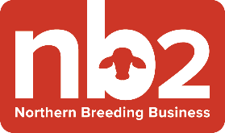
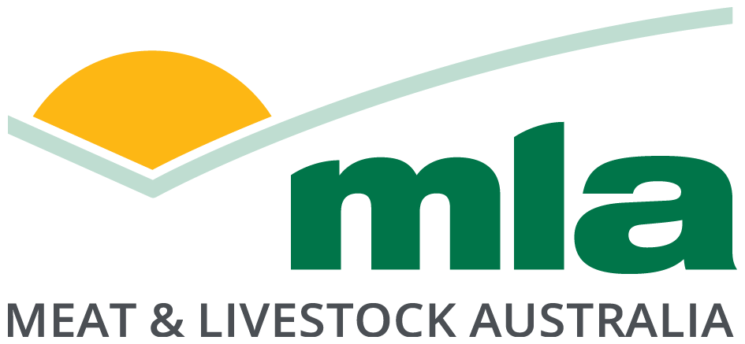

Expression of Interest as a group facilitator for the
Northern Breeding Business (NB2) Program
June 2023
What NB2 is about
The Northern Beef Breeding Business (NB2) program is about bringing producer groups together to share perspectives and ideas on improving enterprise performance with the support of a facilitator and industry experts.
The project focuses on improving productivity and profitability of northern beef businesses by taking a whole of enterprise approach and measuring key indicators in herd, feedbase and business performance. By having access to real data, producers can identify areas for improvement that can increase reproduction rates, reduce herd mortality, improve herd productivity, and make measurable changes in their businesses.
How it works
The NB2 program is producer-driven, bringing together groups of producers to identify their own priorities for business improvement, learning, and professional development. The real benefits come from the discussions within the groups, when members can get each other to think outside their day-to-day operations, learning from what their peers are doing, and exploring new opportunities.
After completing standardised training and data collection, each producer will receive a confidential analysis on their business performance. From there, groups will discuss and identify improvements to focus on together, accessing experts and extension support to align to their interests and business priorities. Groups will repeat this cycle twice so they can measure the impact of interventions and foster a culture of continuous improvement. Each business will contribute $2000 per year that will be matched by the MLA Donor Company to form a group fund which can be drawn upon for training and development activities identified through the NB2 process.
The role of a facilitator is not to be a technical expert but to help bring groups together, provide support in data collection, coordinate training activities and foster constructive discussion using peer-to-peer learning principles. Facilitators will be supported by a group-nominated producer coordinator who organises group activities and training, assists producers with data collection, assists the facilitator in managing the group’s budget and provides leadership for the group.
The program is seeking group facilitators to work closely with future producer groups and the NB2 support team. This document details an expression of interest for the role of group facilitator. Further information on the program can be found at https://www.mla.com.au/nb2

The Role Description
Group facilitators are responsible for:
- Establishing a group of up to 10 beef businesses with a nominated producer coordinator.
- With the producer coordinator, supporting participating producers to collect data throughout the year using standardised templates for livestock schedules, feed budgets and financial budgets.
- Working with the producer coordinator and producer members to interpret reports generated from the analysed data.
- Facilitating group discussions on the baseline data collection and results (while maintaining individual business confidentiality) to highlight the value of the information collected and identify key areas to focus on.
- Assisting but not directing producers with the evaluation of potential interventions or management practice changes for possible implementation.
- With the producer coordinator, facilitating discussion to identify training/skill building needs required and organise the appropriate training package(s).
- With the producer coordinator, manage invoicing and finance for group funds. This will include invoicing group members annually, receiving matched MDC funds, and managing the group’s account for group activities. More information about the MDC program can be found at https://www.mla.com.au/about-mla/what-we-do/mla-donor-company/
- Providing feedback to MLA regarding the peer-to-peer learning process, the templates used for data collection, R&D priorities, and the Monitoring, Evaluation and Reporting (MER) framework via annual milestone reports and a final report at the conclusion of two years.

The facilitator role will be renumerated up to four days per month plus expenses. In addition to the responsibilities outlined above, facilitators will be required to participate in facilitation training and will have access to a peer network of facilitators across northern Australia, and support from experts in facilitation, feedbase, herd, and business performance.
Facilitators will require a current C class licence driving licence and be willing and able to travel to producer properties, facilitation training, and annual NB2 events.

Selection Criteria
Key selection criteria for selection as a group facilitator are:
- Ability to bring together and work with a group of up to 10 producers.
- Skills in working with people in small groups (peer to peer learning).
- Commitment and participation in NB2 facilitation training and NB2 facilitator network.
- Established network in the north Australian beef industry.
- A track record of achievement and leadership.
- Willingness to travel and attend project meetings (online and in person).
- Ability to capture feedback and data, report on progress and meet project milestones.

Skills Required
Key skills required:
- Group facilitation and peer to peer learning skills.
- Excellent communication skills.
- Ability to motivate and inspire people.
- Conflict resolution and relationship management.
- Ability to use computer systems (including Microsoft Excel, Word and PowerPoint).
- Writing and reporting skills, including monitoring and evaluation.

How to express an interest in the role
Interested applicants are required to provide a summary of no more than 1,000 words outlining skills, knowledge and experience, and the motivation for the role. Applicants should take into consideration the information about the NB2 program when applying. Your application must address the following four questions:
- Describe what would make a good NB2 group facilitator for working with beef producer groups in the northern industry.
- What important knowledge and skills would you bring to the role?
- Describe other similar roles you have worked in & what you see as the three most important abilities of an NB2 facilitator.
- What do you see as the three greatest challenges in this role and how would you address them?

Eligibility
Facilitators must not be a current or past employee of Meat and Livestock Australia within the last 24 months. MLA will require an organisation with ABN and insurances for contracting and invoicing. The organisation must be willing to be engaged using MLA’s standard Umbrella Research Agreement terms, which can be found at https://www.mla.com.au/about-mla/mla-agreements/.
Expression of interest process:
Please email your expression of interest to asmith@mla.com.au by COB 31-Jul-2023.
All applicants will be acknowledged on receipt of the EOI and will be advised of the outcome by 31-Aug-2023.
If successful, MLA will be seeking to establish new NB2 producer groups by November 2023, with training for facilitators occurring soon after.
Further information
For more information on the NB2 program and the role contact:
Ainsley Smith
Project Manager – Beef Productivity
Email: asmith@mla.com.au
Phone: 0474 199 470

