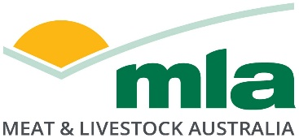

**Tender Specification**

**Literature Review – Establishing the complete farm system biogenic carbon cycle at a farm and national level.**

**Summary:**

Meat & Livestock Australia (MLA) is seeking preliminary applications from organizations (or partnerships of organizations) to conduct a literature review on establishing the complete farm system biogenic carbon cycle at a farm and national level.

**Background**

Grazing livestock are part of a whole farm system and carbon cycle. Net greenhouse gas emissions of the grazing system is the balance between the **emissions** (from livestock, agriculture soils and farm dams, lime application, fertiliser, pasture residues, vegetation or soil carbon loss due to conversion or management of grazing land) and **sequestration** in the farming environment (soils and vegetation). Establishing a net emissions position versus a direct emission position acknowledges the role grazing livestock have in the environment and the biogenic nature of ruminant derived greenhouse gas.

At a farm systems level there are other parts of the carbon cycle that may be able to be incorporated into emissions and sequestration calculations, but further R&D is required to establish measurement technology and frameworks for adequate calculation of these fluxes.

Currently, an unaccounted pool is the annual change in above and below ground carbon stocks of perennial pastures. The Australian National Inventory report (2022) currently assumes an IPCC Tier 1 approach to grassland above and below ground biomass (no net gain or loss), despite soil carbon changes being modelled under grasslands. The IPCC (2006) Guidelines in Section 6.2.1 (Grassland Remaining Grassland - Biomass), discusses allowance for use of Tier 2 & Tier 3 approaches for estimations of changing carbon stocks in grassland where management changes are occurring over time (e.g. through introductions of silvopastoral systems, tree/brush removal for grazing management, improved pasture management or other practices), to account for potentially significant carbon stock changes. The IPCC (2006) states it is *good practice* for countries to strive to improve inventory and reporting approaches by advancing to the highest tier possible given national circumstances.

To enable a framework for inclusion of Biomass in the National Inventory will rely on establishment of measurement technology that can precisely and accurately measure forage across diverse pastures in Australia at an affordable cost.

The flux of methane into soil (by methanotrophic bacteria) and out of soil (under anaerobic conditions) remains to be studied at scale across the diverse grazing lands of Australia. Global methane budgets published in IPCC AR6 Chapter 5 globally indicates soil uptake of methane between 2008-17 of between 30-37 Tg CH4/yr, while enteric methane and manure emissions are reported at 109 Tg CH4/yr. Further research is needed to understand how methane flux on grazing land occurs across different soils and rainfalls and the manner in which human management can influence its flux (e.g. grazing in wetlands, or stocking rate).

Finally, an atmospheric nitrogen cycle also exists, albeit across much longer timeframe, and the roles of legumes, biocrusts, soil types and rainfall in soil nitrogen flux over diverse landscapes requires further research.

MLA continues to invest and support development of soil carbon and vegetation sequestration models. Low-cost methods are required that can predict changes in these carbon pools and fluxes (soil, woody vegetation, pasture biomass) across diverse grazing environments with evaluation of their accuracy and precision relative to current gold standards for measurement.

The end goal of the research program is to establish methods, that if viable and scientifically robust, may at some point be able to be incorporated into either insetting or greenhouse gas inventories in the future. To start this process, MLA wishes to conduct a review of Australian and global peer-reviewed literature on the topic, and seek global examples of current costs of measurement at a farm and national inventory scale.

**Objectives**

Conduct a review of Australian and global peer-reviewed literature.

Preliminary research proposals can target either a single or multiple focus areas below (1. to 4.)

1. **National Grassland Biomass Carbon Inventory**
2. Review technology and/or models that could develop a national grassland biomass carbon inventory.
3. For reviewed technologies and or/models, document the precision and accuracy to measure perennial and annual pasture biomass (above and below ground) at different spatial resolutions
4. Review techniques to determine the proportion of annual and perennial pasture biomass
5. Determine effects of soil type, soil fertility, moisture and temperature influence the ratio of above and below ground biomass across different grassland types.
6. Determine if grazing management influences depth of root systems and survival during extended droughts
7. Determine current cost of measurement on a farm and national basis from domestic and international case examples if available.
8. Based on Objectives (a to f.) determine any research gaps and recommendations
9. **National Soil Methane and Nitrous oxide flux**
10. Review technology and/or models that could develop a national methane and nitrous oxide soil flux model.
11. For reviewed technologies and or/models, document the precision and accuracy to measure methane and nitrous oxide flux into/out of grazing soils at different spatial resolution
12. Review how soil type, soil fertility, moisture & temperature influence methane and nitrous oxide flux on grazing properties.
13. Review effect of fertilisers, legumes, pasture residues and excreted nitrogen from grazing livestock on nitrous oxide flux from soils.
14. Determine effects on Grazing management on methane and nitrous oxide flux
15. Determine current cost of measurement on a farm and national basis from domestic and international case examples if available
16. Based on Objectives (a to f.) determine any research gaps and recommendations
17. **National Soil carbon model**
18. Review technology and/or models that could develop a national methane and nitrous oxide soil flux model, including the current FULLCAM-Roth C model.
19. For reviewed technologies and or/models, document the precision and accuracy to measure soil carbon at different soil profile depths and spatial resolution.
20. Review how soil type, soil fertility, pasture biomass, pasture species, moisture & temperature influence soil carbon gain/loss in grazing systems.
21. Determine current cost of measurement on a farm and national basis from domestic and international case examples if available
22. Based on Objectives (a to d.) determine any research gaps and recommendations
23. **National Woody Vegetation Gain Model**
24. Review technology and/or models that could develop a national woody vegetation gain model on Australian grazing land, including the current FULLCAM model.
25. For reviewed technologies and or/models, document the precision and accuracy to measure woody vegetation gain at different spatial resolutions for common species of vegetation on grazing land in terms of native species and those used in silvopasture timber production.
26. Determine current cost of measurement on a farm and national basis from domestic and international case examples if available
27. Based on Objectives (a to c.) determine any research gaps and recommendations

**Methodology**

Applicants need to develop a robust methodology to achieve project objectives. Quality of brief project design and methods to achieve project objectives including adequate partners, resourcing and expertise to facilitate proposed R&D are selection criterion.

In relation the literature review, methodologies should consider appropriate sampling regimens to ensure, quantifiably, precise and accurate measurements, especially in landscape environments.

This exercise is largely a desktop exercise, but interview of domestic and global experts and inventory teams can occur via Microsoft Teams or equivalent.

**Reporting Requirements:**

The successful applicant will provide milestone reports (if required) and a final report containing the results. Milestone and final reports will be prepared in line with MLA report guidelines and delivered in Microsoft Word format.

In addition to MLA standard reports, the following will also be provided to MLA at the time of delivery of the Final report:

1. a copy of all project data, including meta-data

**Timing:**

The literature review must be completed by a maximum of 6 months for a single focus area. For applications that include all 2-4 focus areas they must be completed by a maximum of 1 years.

**Intellectual Property**

MLA will own all Reports (milestone and final) 100%.

MLA will own Project IP developed 100%.

**Capital Requirements, Budget & Justification:**

This project will be funded 100% by levies.

Quality of budget justification and value for money are both selection criteria. MLA encourages applicants to justify the **Calculation basis of their budget** as thoroughly as possible, and an excel spreadsheet should be attached to the application. Applicants should be detailed e.g. number of trips, mileage, meals, units used, rates, etc. in their justification.

Applications should budget for the following with MLA.

1. Face to Face initiation meeting at service provider site – 1 day
2. Face to Face completion meeting at service provider site – 1 day
3. Monthly Microsoft Teams catch-ups (2 hours)
4. Preparation time for 2 internal industry meetings (via Microsoft Teams)
5. Presentation time for 2 internal industry meetings (via Microsoft Teams)

**Confidentiality:**

By submitting an expression of interest, the applicant will disclose information in the preliminary application form to MLA’s employees, agents, contractors and advisors, for the purposes of this tender process and any legal or MLA policy requirement. Applicants must identify any information that they consider should be protected as confidential information and provide reasons for this.

**Conflict of interest:**

Applicants, research teams or subcontractors with any potential conflicts of interest with Meat & Livestock Australia, NABRC, SALRC, WALRC, Cattle Australia or Sheep Producers Australia, should thoroughly outline these in SECTION 6 – CORPORATE GOVERNANCE DISCLOSURES ANNEXURE of the tender application including how they propose to manage them, if applicable.

**Process:**

For your application to be **eligible for assessment** please complete and submit:

Section 2 of Request for Tender including;

* + 1.1. Details of tenderer
  + 1.3 Proposed subcontractors and Suppliers
  + 1.4 Insurance
  + 1.5 Corporate Governance
  + 1.6 References for both tenderer and subcontractors

Section 3 of Request for Tender including;

* + The relevant MLA Application form obtained from MLA website (note applications in non-standard format will not be accepted).
  + Attachment – Summary of research team qualifications (tenderer and subcontractors), on-time delivery track record, publications/commercialization outcomes in last 5 years.
  + Attachment – Microsoft Excel File of your Budget justification and its calculation basis.

Section 4 of the Request for Tender:

* Confirmation, if successful, the tenderer will enter into an agreement with MLA on the terms set out in Section 4 or on any previously agreed umbrella terms.

Section 5 of Request for Tender

* Signed Declaration witnessed by JP or Solicitor.

Section 6 of Request for Tender

* Corporate Governance Disclosures Annexure.

Section 7 of Request for Tender

* MLA modern slavery Questionnaire.

Applicants submit a Stage 1 application, utilizing the MLA Preliminary Application form (see below), addressing the tender specification. Proposals will be scored against the selection criterion set out in this tender specification. MLA will acknowledge receipt of each application. Applicants will be advised in writing of the success or failure of their application with feedback relative to the Selection criteria. No further correspondence will be entered into after this feedback is provided by MLA.

If an applicant is successful in Stage 1, they will progress to Stage 2 application process.

Once a Stage 2 statement of work and budget justification is completed to MLA’s satisfaction, the application will then be submitted for MLA review. Work commencement is contingent on MLA approval of the proposal and contract execution. Contract execution will involve executing an Umbrella research agreement and Statement of Work. A copy of MLA’s umbrella agreement is available on MLA’s website at <https://www.mla.com.au/about-mla/mla-agreements/http://www.mla.com.au/mla-agreements>

The total approval and contracting process may take 2 to 5 months dependent on project value.

This project will utilize Levy Funding.

Go to [Applying for MLA project funding | Meat & Livestock Australia](https://www.mla.com.au/research-and-development/funding-opportunities/), then navigate to the correct application form.

**Tender Addendums**

Tender addendums will be uploaded to[**https://www.mla.com.au/research-and-development/funding-opportunities/industry-researchers/current-tenders/**](https://www.mla.com.au/research-and-development/funding-opportunities/industry-researchers/current-tenders/)

Applicants should check this website regularly for addendum updates.

**Selection criteria:**

Stage 1 - MLA applications will be reviewed by Meat & Livestock Australia, and selection will be based on assessment against the following criteria:

|  |
| --- |
| Selection Criteria |
| Quality of project design, methods, statistical designs and soundness to achieve project objectives including adequate partners, resourcing, facilities and expertise to facilitate proposed R&D. |
| On-time delivery track record, research publications/commercialization outcomes in last 5 years of project team. References for tender applicant and subcontractors of the last 3 agreements entered into for the provision of goods or services comparable to those set out in this Request for Tender. |
| Timeframe to complete the project |
| Quality of budget justification excel spreadsheet including the calculation basis of line items. |
| Value for money of budget. |

**Project proposal submissions:**

MLA applications must be lodged electronically as Word document to: [tenders@mla.com.au](mailto:tenders@mla.com.au)

Stage 1 MLA Applications must be received by 1700 AEST on August 15th, 2025.

Strict adherence to the time deadline for applications will occur. Incomplete request for tender applications without the required documentation will not be assessed.

**Further information:**

tenders@mla.com.au

Research & Development

Meat & Livestock Australia

**Section 3.0 Appendix 1. Subcontractor/collaborator organisation declaration**

A signed declaration must be provided to MLA for each subcontractor or collaborator organisation nominated in the MLA application.

**Contribution/Payment Table**

|  |  |  |  |
| --- | --- | --- | --- |
| **Item** | **Cash Contribution to Lead Organisation (if not providing cash directly to lead organisation put N/A)** | **In-Kind**  **(nominate any in-kind contributions)** | **Cash payments**  **(list any cash-payments required from MLA or lead organisation)** |
| **Details of Work to be conducted by Subcontractor/collaborator** |  |  |  |
| **Total Dollars and justification** |  |  |  |

**Declaration**

* I declare our organisation agrees to the methodology and budget outlined in the MLA tender application and Contribution/Payment

By signing below, I am authorised to sign and submit this declaration on behalf of our organisation, and agree to the above declaration and confirm all the above statements to be true.

|  |  |
| --- | --- |
| Name of MLA Tender Application: | |
| Lead organisation submitting MLA tender: | |
| Industry Partner (organisation name): | |
| Industry Partner ACN or ABN: | |
| Authorised representative (name and signature): | |
| Position/Role: | |
| Address: | |
| Phone: | Email: |

**Appendix 2**

**Appendix**

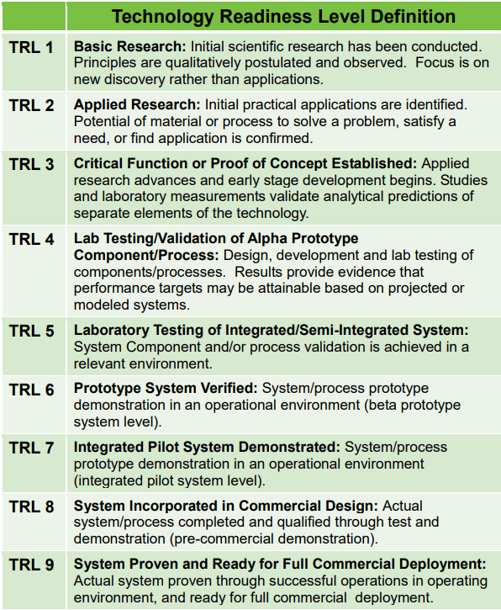

**Market Size Definitions**

Total addressable market represents the number of producers, hectares or revenue for an opportunity that could be solved by a R&D solution.

The total serviceable market is the portion of the addressable market that could be serviced considering factors like geographic reach and distribution.

The total obtainable market is the proportion of the serviceable market that you can realistically capture and will actually adopt your R&D solution based on historical performance, awareness of your company or solution and competition.