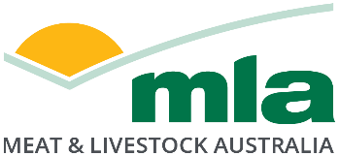

Terms of reference
Sheep Productivity Investment Call

Development of a multimodal Southern Rangelands resource package for sheep

Summary

Livestock production in the Southern Rangelands of Australia is characterised as extensive grazing systems that employ limited land management practices. With most livestock production occurring in temperate zones, industry resources are often not applicable to these Southern Rangeland environments. Several MLA investments have focused on RDA activities in the Southern Rangelands, but few resources have been created that specifically target sheep production systems. This project seeks to generate a multimodal resource package for producers that are tailored to sheep production in the Southern Rangelands.

Purpose and Background
Southern Rangelands represent 57% of the land mass of Australia (Figure 1), creating $1.4 billion per year in value from extensive grazing (Hacker and McDonald, 2021). The majority of sheep production in the Southern Rangelands largely occurs in regions protected by the 5,400 km Dog Fence (Bailey, 2018), reducing the risk of predation by dingoes and wild dogs. However, pastoral sheep operations that have traditionally focused on Merino wool production have declined over time, shifting towards cattle-dominant production (Grower Group Alliance, 2022; DPIRD, 2025). The shift away from wool into sheepmeat breeds such as the Dorper has increased the productivity and profitability of rangeland environments (Alemseged and Hacker, 2014), but the impact of this on the value of sheep production and subsequent adoption of research outcomes in the Southern Rangelands is difficult to quantify.
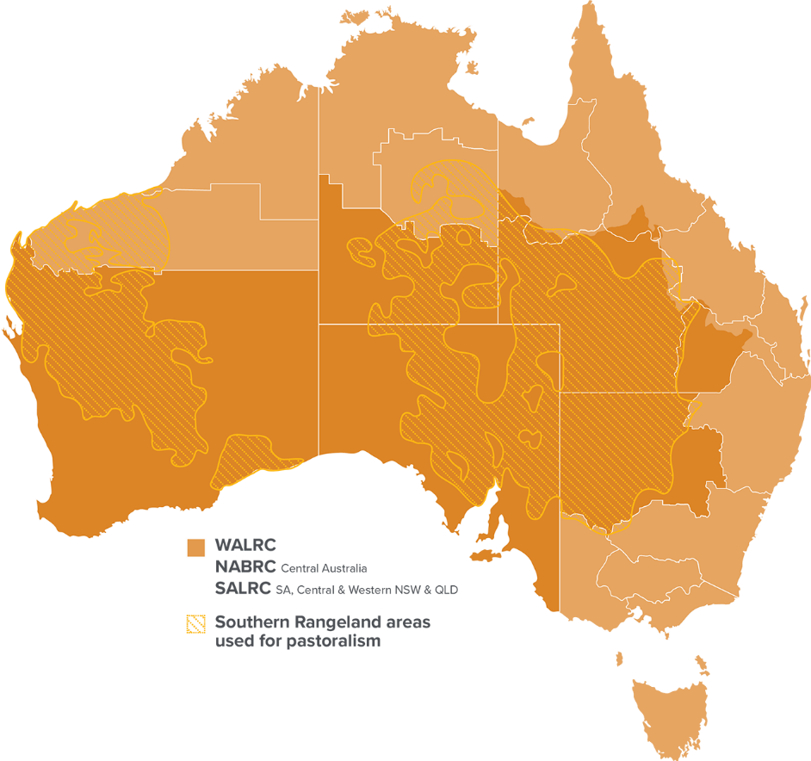
Figure 1. The intersect of Southern Rangeland areas with regional advisory councils (WALRC, NABRC and SALRC).
The sheep reproductive cycle in the Southern Rangelands is limited by variation in feedbase, availability of adequate shelter and the extensive nature of the grazing system, reducing producer control over the breeding cycle. Additionally, maturity at first cycle and consequently ovulation and embryo survival have also been detailed as constraints on reproductive output in extensively-managed sheep (Martin et al. 2024). Beyond recommendations for protein, energy and mineral supplementation in dry, pregnant or lactating ewes (O’Reagain and McMeniman, 2002), literature detailing sheep reproduction management in the Southern Rangelands of Australia is limited. Consequently, an absence of best practice recommendations for sheep reproduction in rangeland production systems has often relied on adapting outcomes from grey resources designed for temperate or Mediterranean climate zones. Subsequently, anecdotal losses occurring between lamb marking and weaning have been amplified by a lack of dedicated best practice messaging tailored to the rangelands environment for Merino and shedding sheep genotypes.
Meat & Livestock Australia has invested in Producer Demonstration Site (PDS) activities, notably ‘Making Maidens Weight’, which aims to understand the relationship between fertility and ewe weight at joining over several years. Utilising PDS principles, the project will identify a minimum liveweight target that suits management, breeding and business objectives for producers. Further, other PDS activities, including ‘Lamb Survival – South-East Queensland Rangelands’ aimed to utilise objective management practices and technologies to better understand lamb survival in the semi-arid rangelands, and ‘Pregnancy scanning in extensive sheep flocks’ PDS project sought to optimise management of breeding ewes through adapting pregnancy scanning strategies to include foetal age and number in wet/drying of ewes in Southern Rangelands environments.
Irrespective of sector, producer uptake of digital and print media is directly influenced by the high variability of their enterprise, limiting their ability to routinely consume content. Commercial surveys have indicated that there remains some scepticism toward social media as a means of communication (ACM Agriculture, 2024a), and a combination of print and digital media is most effective at engaging farmers (76%; ACM Agriculture, 2024b). As such, a unilateral engagement approach to encourage adoption is not fit for purpose for Australian producers. The Southern Rangelands Grazing Land Management course was an example of a multimodal training package delivered to South Australian pastoralists, landholders and land managers. Across 11 workshops, 84% of attendees were producers with satisfaction scores averaging 9.4/10 and 92% of producers indicating their intention to change a practice (L.ADP.2301). However, EDGEnetworks operate under a commercial delivery model with technical content retained as course-only materials. There exists an opportunity to repackage sheep production information into shorter, topical fact sheets and learning modules that are freely accessible for producers and advisors.

Expected outcome
Proposed RD&A activities will meet agreed milestones identifying progress in achieving one or more of the objectives and outcomes identified in this TOR which align with producer priorities put forward for investment by the Red Meat Panel.

Scope

MLA is calling for applications for levy-funded projects from service providers with rangeland expertise that will consider the following objectives:
- Undertake a systematic review of the academic and grey literature targeting the sheep reproductive cycle in Southern Rangelands production systems. Where possible, this should include key industry insights from sheep veterinarians, consultants and affiliated industry stakeholders. The review should also include an identification of R&D knowledge gaps for Southern Rangelands systems.

- Using existing MLA resources, review, design and deliver a multimodal (digital and print media) best practice resource package for Southern Rangelands sheep production and reproduction.

- Design and promote an e-Learning package tailored to best practice sheep production and reproduction in the Southern Rangelands

- Develop and execute a multimedia engagement strategy to enhance producer, landholder and land manager awareness and engagement in the Southern Rangelands.
Prospective service providers should consider the use of a variety of online education and multimedia tools.

Proposed activities
The prospective service provider will be required to undertake a systematic review of the academic and grey literature, identifying current knowledge and opportunities for future R&D targeting the sheep reproductive cycle in the Southern Rangelands. Additionally, the service provider will design a multimodal resource package for Southern Rangelands sheep production. Building on existing resources, the service provider will repackage these into a range of print and digital media, without duplicating content featured in the Southern Rangelands Grazing Land Management or EDGEnetwork courses. Further, the project should encompass the development and execution of an engagement strategy to enhance producer, landholder and land manager engagement. The prospective service provider will be required to work with MLA to incorporate case studies and other promotional material into existing MLA publications (e.g. Feedback magazine).
In line with the MLA Southern Rangelands Hub definition and as defined in Figure 1, Southern Rangelands in this TOR are considered areas within South Australia, Central and Western New South Wales, Queensland and Western Australia that have: 1) extensive grazing enterprises in beef, sheep and goats; 2) semi-arid and arid environments; 3) a native pasture base and 4) low rainfall patterns (< 450 mm p.a.) with high variability, low seasonality or winter dominance.

Other requirements

All projects will be required to implement a comprehensive monitoring, evaluation and reporting (MER) plan aligned to the MLA framework to demonstrate producer engagement, practice change and the benefit to the production businesses and broader industry. A copy of the MER plan guidelines is available here. The MER plan will be a requirement of milestone one if the project is successful. Please budget for MER in this proposal.

Project duration and timing
The project is anticipated to be contracted in FY26, with a duration of up to 18-months.

Resources Required
The proposal should include all resources, personnel and budget required to complete the project.

Important information and selection criteria

This proposal will encompass research, development and adoption (RD&A) activities in the Producer Adoption sub-program that achieve outcomes in line with the priorities of the Southern Australian Livestock Research Council (SALRC).
MLA is seeking full RD&A proposals to generate a multimodal resource package from existing resources that are tailored to the Southern Rangelands to improve communication of RDA outcomes to producers. Proposals will be reviewed by MLA to assess alignment with key RD&A priorities.

Funding mechanisms
The successful project will be funded via the sheep levy funding stream. For projects to be funded, they must be endorsed for funding by Red Meat Panel prior to progressing through the MLA governance process. For more information on the goat levy funding system please see here.

Confidentiality and intellectual property
The successful applicant will be required to enter into an Umbrella Research Agreement with MLA. A link to the template is provided in section four of the request for tender document.
Applicants must identify any background intellectual property (BIP) brought to the project and bring any background IP required that is not owned by MLA. All data and cited references must be acknowledged in the final report and it is the sole responsibility of the applicant to ensure copyright laws are not breached.
Where further information is available which may assist the successful applicant in meeting the requirements of the project, MLA will provide such information to the successful applicant.

Deadline for submissions
Full proposals must be received by MLA before 11.59pm (AEDT) Friday 27 March 2026. Late proposals will not be accepted.
Use the full application template to submit proposals electronically to MLA at: projectcall@mla.com.au
Full proposals will be acknowledged and recorded on the MLA project information system.

Further Information
If you have questions about these terms of reference, contact:

Dr. Melanie Smith  Program Manager – Sheep and Goat Productivity  msmith@mla.com.au  +61 499 649 072 | Dr Daniel Forwood  Project Manager - Sheep and Goat Productivity  dforwood@mla.com.au  +61 457 477 537

