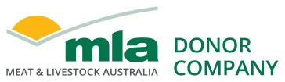

Final report

Beauty Food snacks with inclusion of Australian red meat - product and market development (Chief Nutrition)
Project code: P.PSH.1220
Prepared by: Justin Babet and Brock Hatton
Chief Nutrition Pty Ltd

Date published: 31 May 2021

PUBLISHED BY
Meat & Livestock Australia Limited
PO Box 1961
NORTH SYDNEY NSW 2059

This is an MLA Donor Company funded project.
Meat & Livestock Australia acknowledges the matching funds provided by the Australian Government to support the research and development detailed in this publication.
This publication is published by Meat & Livestock Australia Limited ABN 39 081 678 364 (MLA). Care is taken to ensure the accuracy of the information contained in this publication. However MLA cannot accept responsibility for the accuracy or completeness of the information or opinions contained in the publication. You should make your own enquiries before making decisions concerning your interests. Reproduction in whole or in part of this publication is prohibited without prior written consent of MLA.

Abstract

This project was undertaken because the global collagen market, currently valued at over US$3.6 billion, is growing rapidly with growth being led by bovine collagen within the food and beverage sector. At present, however, Australia does not produce bovine collagen - derived from cattle hide - for use in food. In many cases it is cheaper for graziers to bury hides in landfill than incur the cost of processing in order to sell them.
At Chief Nutrition, we have had rapid growth in the Australian market, and are growing into export markets, for our range of bovine collagen protein bars/cookies and innovative jerky style products including our beef protein bars. While we source our beef from Australia, we currently source our bovine collagen from Argentina because there are no Australian bovine collagen suppliers.
This project explored “where to play and how to win” in developing new products and markets for Australian red meat origin components such as bovine collagen. We conducted market research including a market visits in Australia and the Middle East, and online interviews with key stakeholders in China and the US. Feedback from that research guided the development of our minimum viable products which have now been successfully commercialised and are selling both domestically and internationally.
In addition to revenue generated by Chief Nutrition, key benefits to the industry include identifying and validating a global opportunity for what is essentially a waste product of the beef industry. We estimate that AU$3 billion of additional annual revenue could be generated by the Australian beef industry if all hides of beef cattle were processed into bovine collagen powder. Furthermore, we estimate that AU$11 billion of additional annual revenue could be generated by the Australian beef industry if cuts such as brisket and topside were sold as part of a value-added product such as our beef bars, rather than as raw produce.

Executive summary
Background
By 2027, the global collagen market is expected to grow at a CAGR of 6.9% to reach US$7.5 billion. The growth of this market is mainly attributed to the growing use of collagen in food, particularly relating to protein consumption and nutricosmetics.
Based on source, the collagen market is segmented into bovine, porcine, fish, chicken, sheep, and other sources. The bovine segment is estimated to command the largest share of the overall collagen market. This large share is mainly attributed to its several health benefits, such as skin health, tendon reinforcement, bone loss prevention, and arthritis relief. Thus, making bovine collagen one of the most widely used and accepted collagens.
Based on application, the collagen market is mainly segmented into food and beverage, pharmaceuticals, nutraceuticals, healthcare, cosmetics, and technical applications. The food and beverage segment is estimated to command the largest share of the overall collagen market.
The North American region is estimated to command the largest share of the overall collagen market. However, the Asia-Pacific region is expected to grow at the highest CAGR over the coming years, providing regional and global opportunities for Australian bovine collagen producers.
Currently, Australia does not have any producers of bovine collagen for the food and beverage segment. This project set out to determine the market opportunity for Australian bovine collagen, and other value-added red meat products, in the global food segment.
We focused on snacks because this is one of the fastest growing segments of food, in additional to continued growth in healthy and sustainable food options. The results of this research will be used to help establish an Australian bovine collagen market, and the development of further innovative, value-added red meat products.

Objectives
The main objectives of this project were to:
- Evaluate Australian sourced bovine collagen protein sources against international suppliers.
- Develop proof of concept bovine collagen and other innovative red meat-based snacks and test in-market. This included assessing the value proposition for Australian sourced bovine collagen and beef snacks domestically and internationally.
- Provide an overview of the available market, target usages and occasions and users.

Methodology
- Analysis of the potential value created by converting raw beef into high value bovine collagen products and innovative, shelf stable beef snacks.
- Interviews conducted with key stakeholders including distributors, retailers, consultants and consumers domestically and internationally to understand the opportunity for Australian sourced collagen products and beef snacks. This included market visits in and the Middle East and stakeholder interviews in the US and China.
- Analysis of the size of each market, demographics and buying behaviour of consumers. Also reviewed potential competitors in each market to understand sales volume, pricing and their unique selling propositions.
- Data was used to guide development of minimum viable products. Minimum viable products were shared with key stakeholders domestically and internationally and surveys conducted to gain deeper insights into taste, texture, product market fit, pricing and our unique selling propositions.

Results/key findings
- Assuming an average hide weight of 20kg and a 20% yield of collagen powder per hide, 10,000 head of cattle will produce 40,000kg of bovine collagen valued at AU$17/kg wholesale, AU$60/kg retail, and over AU$100/kg if sold as part of a valued added product.
- Assuming an average weight of 350kg, 10,000 head of cattle will produce 350,000kg of topside and brisket valued at over AU$70/kg when sold as part of a valued added product.
- Completed testing of our minimum viable products, including bovine collagen protein bars and dried beef bars, and have successfully launched these products in-market.
- Established a commercially viable market for Australian sourced bovine collagen protein and other innovative meat snacks in Asia Pacific (particularly in China) and the Middle East where consumers are attracted to “clean and green” Australian sourced products. We are now selling our products in the Middle East and are in discussions with distributors in China and Japan.
- While Australian sourced is less appealing to consumers in North America, we have determined there is high demand for “Regeneratively Farmed” bovine collagen and meat snacks which represents an opportunity for Australian farmers following regenerative practices, and manufacturers utilising regeneratively farmed products.
- Identified an Australian based manufacturer capable of processing Australian bovine products into high quality bovine collagen powder that can and will be used in our products.

Benefits to industry
- Assuming an average hide weight of 20kg and an average price of $20, the price of raw bovine hide is around $1/kg. If sold as part of a value added bovine collagen product for over $100/kg, this would result in a value multiplier of over 100x the raw material price.
- The price of raw beef (processed) is around $11/kg. If sold as part of a value added beef product for over $70/kg, this would result in a value multiplier of almost 7x the raw material price.
- The development of an Australian bovine collagen product / industry, and meat based snacks, could create additional and viable red meat supply chains for Australian red meat processors.

Table of contents

1 Executive summary 3
1. Background 6
2. Objectives 6
3. Methodology 7
3.1 Australia and the Middle East 7
3.2 China and the US 7
4. Results 8
4.1 Australia 8
4.2 The Middle East 9
4.3 China 9
4.4 United States 9
4.5 A viable business model 10
5. Conclusion 10
5.1 Key findings 10
5.2 Benefits to industry 11
6. Future research and recommendations 11
7. References 11
8. Appendix 13
8.1 Chief Product Range (eatlikeachief.com) 13
8.2 Beauty Food Product Range (beautyfood.com.au) 14
8.3 Cost Benefit Analysis 14

Background
MLA data from 2019 showed the Australian hide market continuing to struggle with prices declining 50-90% year-on-year.
The MLA report states “This has been an ongoing trend, with prices per hide collapsing since the highs of 2014. The total export value of Australian hides in 2018 was $330 million (IHS Markit), down 17% from 2017 and 19% from 2016. The best large hides (from cattle over 350kg cwt) in Victoria are averaging just over $20/hide, while the same category in NSW are averaging $17/hide and in Queensland just under $10/hide. Nearly all hides from cattle under 350kg cwt are making less than $10/hide, with many small or poor condition hides reportedly holding no market value.”
This problem has the potential to be solved by the creation of a bovine collagen industry in Australia. At present, Australia does not produce bovine collagen, however hides (including small or poor condition hides) have the potential to be processed into bovine collagen powder.
The main question we set out to answer is whether or not there is a market for Australian bovine collagen, and other types of value-added red meat products. If there is, what kind of products could we make, how would we best position them and what export markets would be available. Because we make healthy snack foods, our focus has been on bovine collagen and red meat-based snacks.
Previous projects have set out to analyse technical aspects of collagen production in Australia. The results of this research will be used to generate the traction required to establish an Australian bovine collagen market, and the development of further innovative, value-added red meat products.
We are using the products we have developed as part of this project to create the initial market demand required to get the bovine collagen industry off the ground. We anticipate that once Australian bovine collagen is available, growth into new markets and products will be rapid.

Objectives
The main objectives of this project were to:
Objectives | Objective Met?
Evaluate Australian sourced bovine collagen protein sources against international suppliers. | Yes
Develop proof of concept bovine collagen and other innovative red meat-based snacks and test in-market. This included assessing the value proposition for Australian sourced bovine collagen and beef snacks domestically and internationally. | Yes
Provide an overview of the available market, target usages and occasions and users. | Yes

Methodology

Australia and the Middle East
Our research focused on meeting with key stakeholders in Australia and the Middle East to understand the opportunity for sourcing our collagen in Australia, and increased provenance information with regard to the meat for our beef bars.
To understand the viability of the MENA market, analysis was conducted around the size of market, demographics of those who live there as well as the buying behaviour of the consumers.
An initial online review of potential competitors was also conducted to get a guide on pricing, levels of active ingredients (collagen) and other calls out to use on pack and in communications on online platforms where the products are sold.
A market visit was conducted to canvas potential retailers and understand the competitive offerings that they have access to, that compete with both the Collagen Bar and Meat snack ranges. A comprehensive analysis was conducted to show the brands on offer, types of products, the formats that they are available in, and the price point for each offering. This allowed us to judge elements of desirability and viability for the market.
Meetings with key stakeholders were conducted throughout the MENA region to complete the understanding of desirability and viability of our existing products, as well as the additional equity, that an Australian made collagen product would hold over existing products in the market. Each of these stakeholders were asked questions relating to the existing range under the Beauty Food and Chief brands to assess their interest in the products based on product/market fit attributes including; acceptable pricing levels, key call outs, form and function of the product and willingness to purchase the product through their specific channel. The respondent was then asked if having Australian made collagen in the product would have positive or negative impact on their view of the product and if it would change the value proposition as well as pricing. As we are currently looking at sourcing an Organic bovine collagen this was also discussed as to its impact on the value proposition for their consumers.

China and the US
The feedback we received from the Middle East resulted in further testing with our current and new potential manufacturers, food technology providers, ingredient suppliers and packaging suppliers/designers.

Due to COVID-19 related travel restrictions, market field visits were severely hampered, however we continued to collect market feedback by mailing samples of our products and conducting online meetings via Zoom. This included further testing of our Value Proposition in other international markets with a focus on China and the US.

To understand the viability of international markets we took the following approach:
- Initial analysis around the size of each market, demographics of those who live there as well as the buying behaviour of the consumers. This helped us determine the top markets for us to focus our attention.
- Identified and contacted potential distributors, retailers and consultants that might be able help us enter the relevant market.
- Conducted online meetings with these distributors, retailers and consultants to review our products, collect feedback and gain an understanding of desirability and viability of our existing products, as well as the additional equity that an Australian made collagen product would hold over existing products in the market. Each of these stakeholders were given the opportunity to share products with their own customers and then were asked questions relating to our products to assess their interest based on product/market fit attributes including acceptable pricing levels, key call outs, form and function of the product and willingness to purchase the product through their specific channel. The respondent was then asked if having Australian made collagen or beef in the product would have positive or negative impact on their view of the product and if it would change the value proposition as well as pricing. As we are currently looking at sourcing an organic regeneratively farmed bovine collagen this was also discussed as to its impact on the value proposition for their consumers.
- Leveraged the market insights gained from these conversations to conduct a further, in-depth analysis of that market including potential competitors, types of products, formats, validation of pricing and other call outs used on pack and in communications on online platforms where they are sold (due to the nature of the US market which is dominated by Amazon, we targeted our research for the US market on Amazon). This allowed us to judge elements of desirability and viability for the market.
- These conversations provided an important insight into the margins required for different partners, from which we have been able to determine if there is a viable business model.

Results

Australia
Confirmed strong demand in Australia for Australian made bovine collagen. Confirmed demand for better provenance information relating to value-added Australian beef products, particularly sustainable sources:
- Our Australian distributor and retail customers in Australia confirmed that there is strong interest and added value associated with the Australian call-out value proposition for both Australian sourced meat (particularly with more detailed provenance information) and Australian sourced collagen.
- An additional value proposition around environmental sustainability was identified in the Australian market. With regard to meat, our distributor and retailers were very interested in sustainable farming practices (particularly regenerative farming). With regard to collagen, our distributor and retailers were very interested in the potential for an Australian made collagen product to reduce the number of cow hides going straight to landfill.
- The typical consumer of collagen products are health conscious men and women. The typical occasion is as a pre-packaged snack or as a protein source to add to mixed drinks such as smoothies.
- The typical consumer of meat snacks are traditionally men, however, our beef bars also gained strong traction with female consumers. These are increasingly health-conscious consumers looking for high protein, low carb, low sugar and preservative free products. The typical occasion is as a snack.

The Middle East
Confirmed strong demand in MENA for Australian made bovine collagen and Australian beef snacks:
- MENA consumers are becoming more nutritionally aware and concerned about their health and wellness. As an example, the government in Dubai has implemented a 50% “sugar tax” for soft drinks and 100% on energy drinks. This shows top down support for health, with a focus on sugar, as they try to reduce their levels of type II diabetes.
- Consequently, there is a greater demand for organic and natural alternatives. Consumers, including working women, live fast-paced and business lifestyles, making convenience and accessibility very important (in other words, they’re increasingly interested in healthy snack options).
- This region also has a large expat community that adheres to western values and trends that are aligned with our Value Proposition.
- The vast majority of products in MENA are drawn from the US and European markets, but Australian made products are perceived very positively and there is strong interest and added value associated with the Australian call-out value proposition (quality, clean/green, etc) for both meat snacks and collagen.
- Typical usage and occasions matched the Australian market.

China
Confirmed strong demand in China for Australian made bovine collagen and Australian beef snacks:
- There is strong interest and added value associated with the Australian call-out value proposition for both Australian sourced meat and bovine collagen in China.
- Chinese consumers are becoming more nutritionally aware and concerned about their health and wellness. However, while they care where products are sourced, they are not as environmentally or nutritionally educated as Australian or US consumers. For example, there would be very little interest in sustainably sourced or low carb/sugar products. The key callouts that resonate in China are those that are outcome focused, for example weight loss and beauty. Edible beauty, in the form of collagen powders and associated products, is one of the top growth sectors in this market.
- Typical usage and occasions matched the Australian market.

United States
Confirmed potential demand in the US for regeneratively farmed bovine collagen and beef snacks:
- The Australian call-out value proposition proved to be less important in the US where US made products are preferred.
- There was however strong interest in the US for regeneratively farmed beef products, mirroring the feedback we had in Australia. This is a rapidly growing area due to an increased interest from consumers around sustainability, particularly as it relates to beef. This appears to be driven by “fake meat” companies and “plant-based diet” advocates continuing to impact the global conversation about the negative environmental impacts of beef, and the resulting resistance from those who are in or support the beef industry.
- This presents an opportunity for regeneratively farmed Australian beef products (including bovine collagen) to do well in the US market where there are currently few suppliers of regeneratively farmed beef, and there are no suppliers that we know of globally with regeneratively farmed bovine collagen.
- Typical usage and occasions matched the Australian market.

A viable business model
While this is an ongoing piece of work, we have shown that we can create a viable business model with scale.

Conclusion

Key findings
- Assuming an average hide weight of 20kg and a 20% yield of collagen powder per hide, 10,000 head of cattle will produce 40,000kg of bovine collagen valued at AU$17/kg wholesale, AU$60/kg retail, and over AU$100/kg if sold as part of a valued added product
- Assuming an average weight of 350kg, 10,000 head of cattle will produce 350,000kg of topside and brisket valued at over AU$70/kg when sold as part of a valued added product.
- Completed testing of our minimum viable products, including bovine collagen protein bars and dried beef bars, and have successfully launched these products in-market.
- Determined there is a commercially viable market for Australian sourced bovine collagen protein and other innovative meat snacks in Asia Pacific (particularly in China) and the Middle East where consumers are attracted to “clean and green” Australian sourced products.
- While Australian sourced is less appealing to consumers in North America, we have determined there is high demand for “Regeneratively Farmed” bovine collagen and meat snacks which represents an opportunity for Australian farmers following regenerative practices, and manufacturers utilising regeneratively farmed products.
- We have identified an Australian based manufacturer capable of processing Australian bovine products into high quality bovine collagen powder.

Benefits to industry
- Assuming an average hide weight of 20kg and an average price of $20, the price of raw bovine hide is around $1/kg. If sold as part of a value added bovine collagen product for over $100/kg, this would result in a value multiplier of over 100x the raw material price.
- The price of raw beef (processed) is around $11/kg. If sold as part of a value added beef product for over $70/kg, this would result in a value multiplier of almost 7x the raw material price.
- The development of an Australian bovine collagen product / industry, and meat based snacks, could create additional and viable red meat supply chains for Australian red meat processors.

Future research and recommendations
- Further research and development of the bovine collagen market should be conducted so that industry is able to understand, and validate, the additional value add opportunities associated with bovine collagen processing/production methods and associated market differentiators for the Australian red meat industry. For example, most bovine collagen is processed using harsh chemicals, therefore there may be opportunities to use other technologies such as freeze drying which may be a differentiator. Testing and analysis of the final products compared to other collagen sources will be required.
- Additional research should also be conducted into Regenerative Farming so the industry is able to understand, and validate, the additional value add opportunities and increasing pricing opportunities associated with regeneratively farmed beef in the global market.

References
Global Collagen Market (2020 to 2027) - Growing Food Processing Industry Presents Opportunities (https://www.prnewswire.com/news-releases/global-collagen-market-2020-to-2027---growing-food-processing-industry-presents-opportunities-301195074.html)

This New Food Label Will Mainstream Whole Foods’ Biggest Trend For 2020 (https://www.forbes.com/sites/daphneewingchow/2019/12/20/this-new-food-label-will-mainstream-whole-foods-biggest-trend-for-2020/?sh=7d491e843933)

What international brands must know about the domestically dominated healthy snacks market in China (https://daxueconsulting.com/healthy-snacks-market-in-china-daxue-consulting)

Australia Snack Bar Market - Growth, Trends, Covid-19 Impact, And Forecasts (2021 - 2026) (https://www.mordorintelligence.com/industry-reports/australia-snack-bar-market)

Australia Is Overdue For A Meat Snacks Revolution, Jodie Minotto (https://www.mintel.com/blog/food-market-news/australia-overdue-for-meat-snacks-revolution)

Appendix

Chief Product Range (eatlikeachief.com)
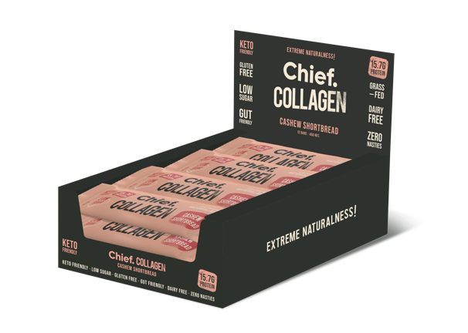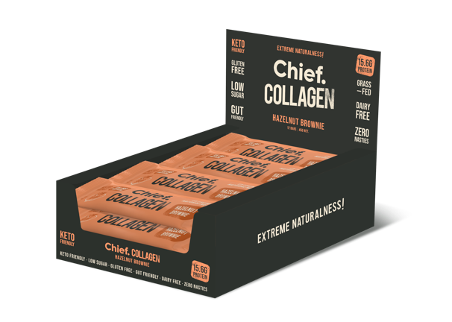
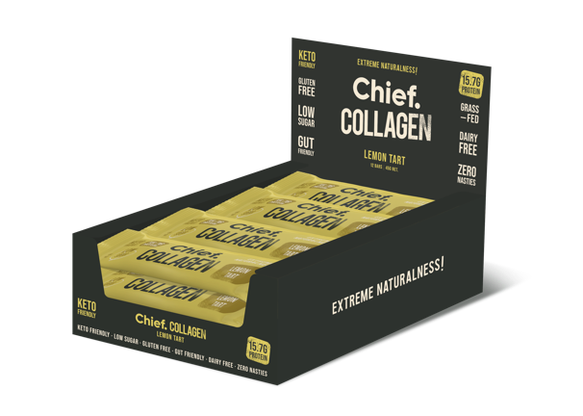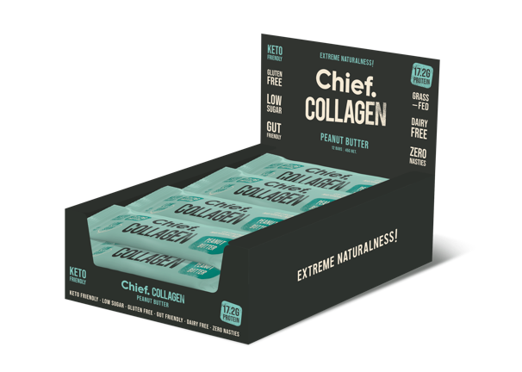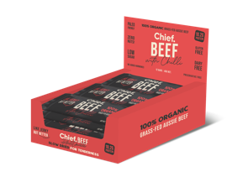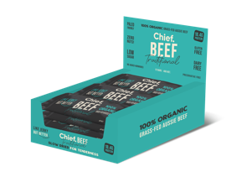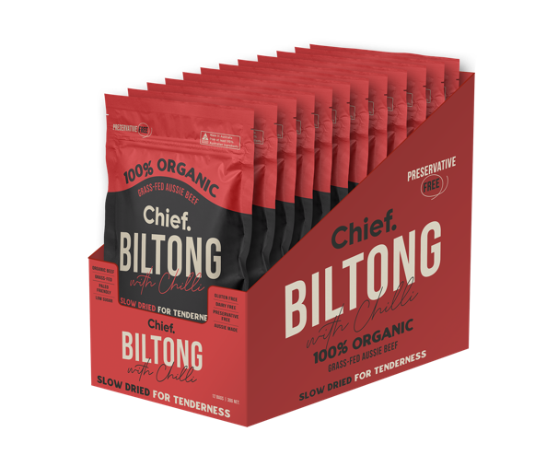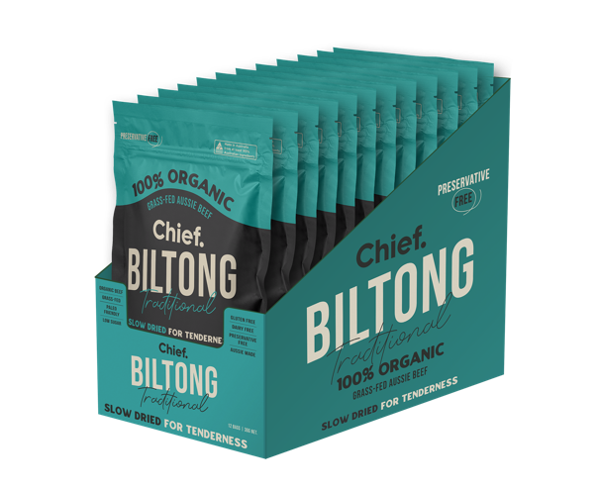

Beauty Food Product Range (beautyfood.com.au)
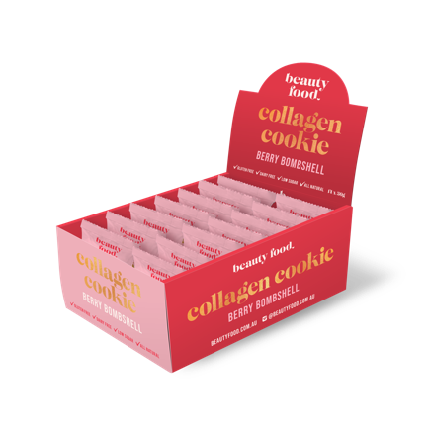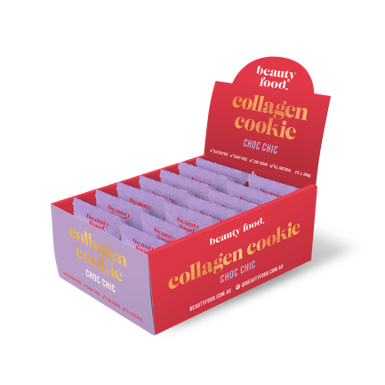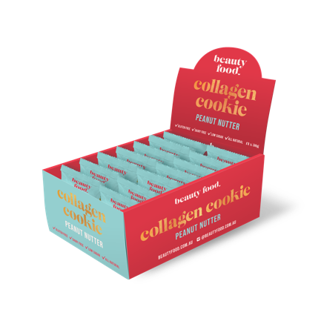

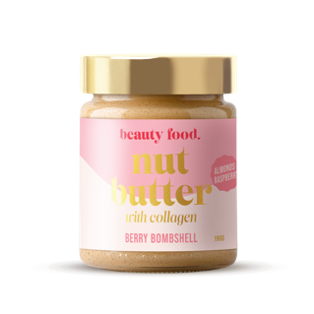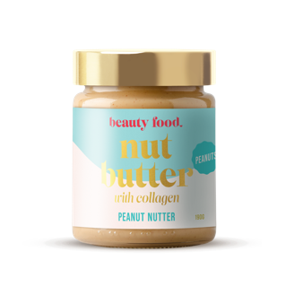

Global Collagen Market (2020 to 2027) - Growing Food Processing Industry Presents Opportunities (https://www.prnewswire.com/news-releases/global-collagen-market-2020-to-2027---growing-food-processing-industry-presents-opportunities-301195074.html)
This New Food Label Will Mainstream Whole Foods’ Biggest Trend For 2020 (https://www.forbes.com/sites/daphneewingchow/2019/12/20/this-new-food-label-will-mainstream-whole-foods-biggest-trend-for-2020/?sh=7d491e843933)

